Individualizing BrB for Your School

Checklist:
____Defined and assigned roles
____Defined expectations
____Customized BrB Point Card
____Selected Break Options
____Determined Break Tracking Protocol
____Determined Incentive System
____Determined Fading Criteria and Graduation Plan

Role and Characteristics | Who is in Charge?
Oversee Training and Implementation
Fluent in BrB
Respected by students
Respected by adults
Communicates effectively with all in school
Time available to coordinate BrB and train others in implementation
Efficient and effective at task completion
Check Students In and Out
Fluent in BrB
Respected by students
Respected by adults
In school every day
Flexible schedule in morning and afternoon
Oversee Data Collection and Progress Monitoring
Fluent in BrB
Time available to collect and monitor data at least weekly
Understands data-based decision-making
Connected to IPBS team
- Define and Assign Roles

School Expectation | Academic Definition
Be Respectful
Be Responsible
Be Safe
- Define Expectations

- Brainstorm and Select Break Options
TBSP BREAK OPTIONS
1. Daydream quietly at your desk
2. Put your head down
3. Read or look at a booj
4. Doodle
5. Color
6. Stretch in the back of the room
7. Run an errand for the teacher
8. Play with putty
9. Move to a separate desk for quiet activity
- Customize BrB Point Card
TBSP BrB Point Card
Name |  |  | Date
 | Expectation | Expectation | Expectation
 | Academic Behavior | Academic Behavior | Academic Behavior | Breaks taken the right way (if needed) | 2-minute breaks I can take
1st | 0 1 2 | 0 1 2 | 0 1 2 | 0 1 | B B B
2nd | 0 1 2 | 0 1 2 | 0 1 2 | 0 1 | B B B
3rd | 0 1 2 | 0 1 2 | 0 1 2 | 0 1 | B B B
4th | 0 1 2 | 0 1 2 | 0 1 2 | 0 1 | B B B
5th | 0 1 2 | 0 1 2 | 0 1 2 | 0 1 | B B B
6th | 0 1 2 | 0 1 2 | 0 1 2 | 0 1 | B B B
Points
2 Met expectations (Great job!)
1 Met some expectations (Good work!)
0 Met few or no expectations (Room for improvement)
Check-In Points Attends check-in 0 1
Was prepared 0 1
Check-Out Points Attended check-out 0 1
Teacher completed ratings 0 1
Bonus Points (breaks ______
taken appropriately, if needed)
Today’s Goal_____ Today’s Total_____ Goal Met? Yes No
Parent Signature
All work due is complete ___________________________

All work due is not complete ________________________
Questions to consider:
- At what intervals will students receive feedback?
- How many points will be on the rating scale?
- Will the point card include space for teacher comments?
- How will copies be made? Who will make them?
- Where will the Point Cards be stored?
- Who will input the data from the Point Cards?
- How does a student get a spare card if one is lost or the student misses check-in?
- Determine Break Tracking Protocol

  - OPTION A: Student keeps Point Card during class and crosses off “B” marks each time a break is used
    - Pros:
-Easy
-Student only has to carry Point Card and Break Protocol Card
    - Cons:
-Student unlikely to interact with teacher at the start of class
-Teacher and student may forget to meet at the end of class for feedback

  - OPTION B: Student is given Break Cards (such as laminated index cards with the letter B on the front) to exchange for breaks
    - Pros:
-Student interacts with teacher at the start of class to hand-in Point Card
-Tangible reminder of available breaks
    - Cons:
-Extra materials for student to carry
-Less subtle; teacher has to go to student to collect card

  - Select corresponding Break Protocol Card from TBSP resources:

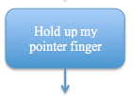
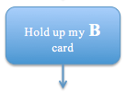
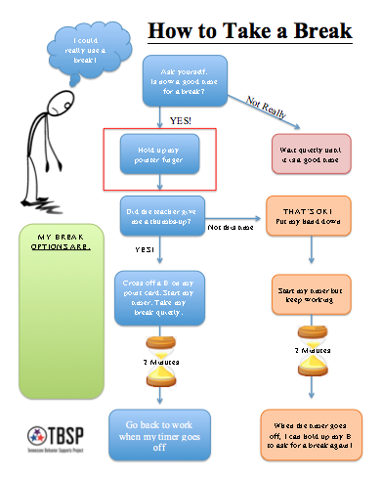
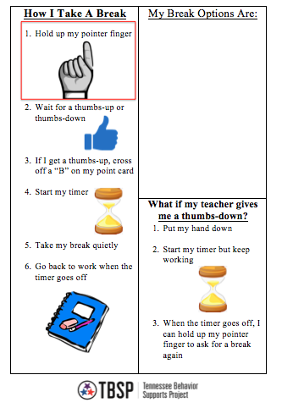
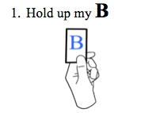
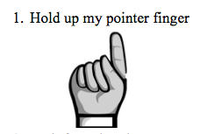
OPTION B
OPTION A
Template 2
OPTION A

OPTION B
Template 1

- Determine Incentives

Breaks are Better Incentive System
What can be earned:
(Specific BrB prizes? Points towards school incentive store? Other?)
Who can earn (insert incentive system title):
BrB students who meet their goals!
How it can be earned:
(Cashing in points? Meeting phase goals? Other?)
Where can it be earned:
(School store? BrB Coordinator’s classroom? Other?)
When it can be earned:
(When enough points are earned? After completing BrB? At the end of each phase? Other?)

Questions to consider:
  - What incentives can a student earn?
  - How frequently can a student earn incentives?
  - Are incentives earned by “cashing-in” points or by meeting pre-set goals?
  - What does a student receive when they “graduate” from BrB
  - Where will we document the incentive system?

- Determine Fading Criteria and Graduation Plan

Questions to consider:
- What is the goal for making adequate progress?
- What happens if a student is far below the progress goal?
- What happends if the student is just below the progress goal?
- What is the goal for graduation from BrB?
- How does graduation occur?

TBSP Suggested Fading Criteria:
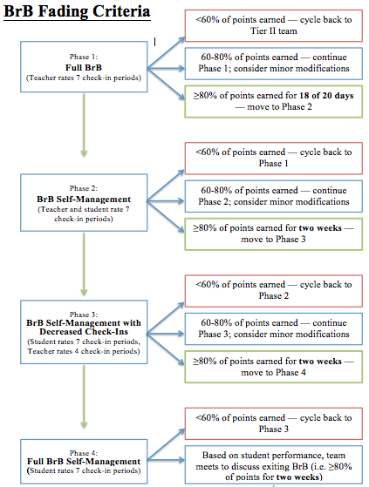
See Fading Criteria Flowchart in Resources

