

INSERT SCHOOL NAME

Response to Instruction and Intervention for Behavior (RTI2-B)

Implementation Manual

2018-2019

Implementation Plan designed by the RTI2-B School Team Members:

INSERT TEAM MEMBER NAMES HERE

Table of Contents

RTI2-B Overview 3

Tier I Documents 5

Purpose Statement 5

Tier I Team Roles & Responsibilities 5

Tier I Team Meeting Foundations Form 6

Tier I Team Meeting Agenda 6

Behavioral Expectations and Behavioral Expectations Matrix 6

Lesson Plans 7

Calendar 7

Teaching the Plan 7

Planning for Stakeholder Input 7

Acknowledgement System Matrix 7

Problem Behavior Definitions and Office-Managed vs. Staff-Managed Chart 8

Discipline Process Flowchart 8

Office Discipline Referral Form 8

Data Collection Plan 8

Appendix 8

# RTI2-B Overview

Response to Instruction and Intervention-Behavior (RTI2-B) is a Multi-Tiered System of Supports (MTSS) that offers a powerful, evidence-based approach for meeting the behavioral and social needs of students in Tennessee schools.

RTI2-B is a promising framework for prevention and intervention within an integrated, three-tiered approach. Each tier of the framework involves careful reflection on the needs of students, the design of interventions matching those needs, and the collection of data to evaluate progress (individually for students and collectively as a school). All of these efforts require a shared school-wide commitment to teach and reinforce positive behavior. It also involves adopting an optimistic view that all students can learn appropriate behavior if sufficient and supportive opportunities to learn are provided. When using positive behavior supports in all three tiers (e.g., focusing on teaching students the behaviors we want to see, as opposed to punishing the behaviors we don’t want to see, and developing relationships between students and school staff), schools create a culture where all students and teachers are respected and included in their community. Furthermore, student and staff contributions to the school create a positive and proactive way to acknowledge, engage, and respect all stakeholders.

The purpose of RTI2-B is to empower educators to equip all students with the opportunity to meet high expectations regarding behavior and the support to reach every student. Also, students, families, and educators can work together to develop and contribute to a shared school vision. Tennessee Behavior Supports Project can help schools meet that goal.

 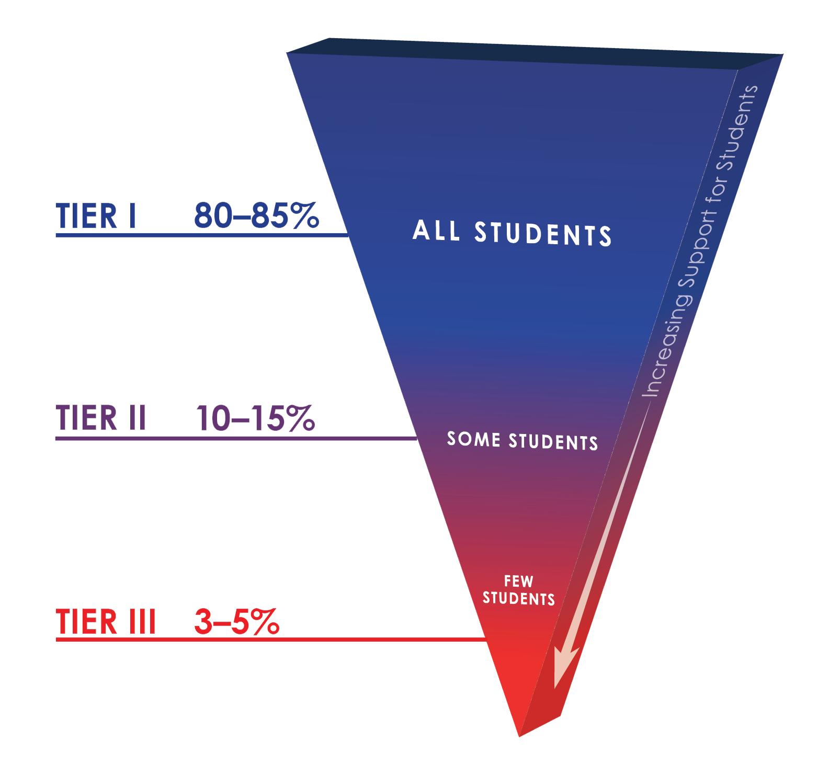

Within the multi-tiered framework of RTI2-B, each tier increases the intensity of intervention and supports so students can be best supported within their school.

**Tier I:** Tier I focuses on the behavioral and social needs of all students across the school environment. Approximately 80% of students typically respond to this level of support. Tier I includes establishing school-wide expectations to support a sense of safety and inclusion among students and staff, teaching and modeling those expectations within different settings throughout the school, positively acknowledging students and staff who follow these expectations, having a formal system for responding to inappropriate behavior, and maintaining a school-wide system where all stakeholders’ opinions are valued.

**Tier II:** Tier II involves delivering more targeted interventions for approximately 10-15% of students who do not respond to Tier I supports. Tier II interventions are provided in addition to Tier I supports in place for all students in the school. Interventions at Tier II are typically systematic, evidence-based interventions that are delivered to groups of students at a time. For example, Tier II interventions typically include small-group social skills instruction, behavior contracts, self-monitoring plans, and check-in/check-out.

**Tier III:** Tier III includes individualized interventions for approximately 3-5% of students who do not respond to Tier I or Tier II interventions and supports. Tier III interventions involve the implementation of specialized, one-on-one systems for students. Examples of Tier III supports include individualized counseling and function-based interventions.



# Tier I Documents

# Purpose Statement

INSERT PURPOSE STATEMENT HERE (see Activity #2 in Day 1 Workbook).

**RTI2-B School Team**

# Tier I Team Roles & Responsibilities

|  |  |  |  |
| --- | --- | --- | --- |
|  | **Before** Meeting | **During** Meeting | **After** Meeting |
| **Team Lead** | * Schedules meetings * Sets meeting agenda * Sends meeting reminders | * Facilitates discussion * Follows meetings norms and provides input | * Follows up on assigned tasks * Completes assigned tasks |
| **Recorder** | * Creates meeting minutes * Sends agenda before meeting | * Records meeting minutes * Reviews action items with team * Respectfully participates in meetings | * Shares minutes with team * Completes assigned tasks |
| **Data Analyst** | * Prepares data and graphs * Review Agenda | * Leads discussion on data * Respectfully participates in meetings | * Completes assigned tasks |
| **Communicator** | * Collects input from staff to share at the meeting * Review Agenda | * Represents staff voice * Considers what training staff will need * Respectfully participates in meetings | * Shares updates with all staff * Completes assigned tasks |
| **Time Keeper** | * Reviews agenda | * Keeps team on topic * Monitors time needed to discuss agenda * Ensures meetings start and end on time * Respectfully participates in meetings | * Completes assigned tasks |

# Tier I Team Meeting Foundations Form

Our RTI2-B Tier I Team reflected on the professional behaviors that characterize efficient and effective meetings during their training. The working agreements are listed below in an effort to support the team’s productivity.

INSERT TEAM MEETING FOUNDATIONS FORM BELOW (see Activity #3 in Day 1 Workbook)

# Tier I Team Meeting Agenda

Our RTI2-B Tier I Team selected an agenda to use at every team meeting. This will help us have efficient and effective meetings.

INSERT TEAM MEETING AGENDA BELOW (see Activity #3 in Day 1 Workbook)

**Behavioral Expectations**

# Behavioral Expectations and Behavioral Expectations Matrix

Our school’s agreed upon behavioral expectations are operationally defined with examples of what the expected behavior looks like in each location. This will improve clarity and consistency of what is expected throughout the school.

INSERT BEHAVIORAL EXPECTATIONS & BEHAVIORAL EXPECTATIONS MATRIX HERE (see Activity #5 and #6 in Day 1 Workbook)

|  |
| --- |
| Our INSERT NAME OF SCHOOL Behavioral Expectations are called:  INSERT NAME OF EXPECTATIONS |
| 1.  2.  3.  4. |

**Teaching Expectations to Students, Staff, Family and Community**

# Lesson Plans

Lesson Plans are an important way to consistently teach all students the behavioral expectations in all locations throughout the school. Together as a team, we created lesson plans for every setting, and the completed lesson plans are located in the appendix of this implementation manual.

ADD COMPLETED LESSON PLANS TO THE APPENDIX (see Activity #7 in Day 1 Workbook)

# Calendar

The RTI2-B School Team added the RTI2-B Calendar Components to our school calendar in an effort to organize our implementation efforts.

INSERT RTI2-B CALENDAR COMPONENTS CHART HERE (See Activity #20 in Day 2 Workbook)

# Teaching the Plan

Our RTI2-B Team worked through the logistics of teaching the plan to all students, staff, family and community in our school, and the details are listed in the charts below.

INSERT CHARTS FOR TEACHING THE PLAN TO STUDENTS, STAFF, FAMILY/COMMUNITY HERE (see Activity #8 in Day 1 Workbook and Activity #19 & #21 in Day 2 Workbook)

# Planning for Stakeholder Input

Our RTI2-B team discussed possible ways to involve our school community (students, staff, family/community) in developing the RTI2-B framework at our school. We hope to receive their input and continued feedback.

INSERT PLANNING FOR STAKEHOLDER INPUT HERE (see Activity #10 in Day 1 Workbook)

**Acknowledgment System**

# Acknowledgement System Matrix

Our RTI2-B team discussed possible ways to acknowledge students, staff, and family/community throughout the school year in an effort to acknowledge expected behaviors and show appreciation of their continued support.

INSERT ACKNOWLEDGEMENT SYSTEM MATRIX CHARTS FOR STUDENTS, STAFF, FAMILY/COMMUNITY HERE (See Activity #18 in Day 2 Workbook)

**Problem Behavior Definitions and Discipline Procedures**

# Problem Behavior Definitions and Office-Managed vs. Staff-Managed Chart

Our school categorizes problem behaviors as office-managed and staff-managed. We used our school’s discipline handbook and the behavior definitions to determine which problem behaviors will be office-managed and which will be staff-managed in our discipline process. We also agreed on the definitions, examples, and non-examples listed below.

INSERT OFFICE-MANAGED AND STAFF-MANAGED CHARTS HERE (See Activity #9 in Day 1 Workbook)

# Discipline Process Flowchart

Together as a team, we updated our Discipline Process Flowchart and it is provided below. This will help improve consistency on the steps to take when problem behaviors occur.

ADD DISCIPLINE PROCESS FLOWCHART BELOW (See Activity #12 in Day 2 Workbook) (THIS SHOULD TAKE AN ENTIRE PAGE)

# Office Discipline Referral Form

Office Discipline Referral Forms are an important way to collect data on problem behaviors occurring in our school. Together as a team, we checked to see if the essential elements are included in our school’s ODR form, and our updated form is located below.

ADD OFFICE DISCIPLINE REFERRAL FORM BELOW (See Activity #13 in Day 2 Workbook) (THIS SHOULD TAKE AN ENTIRE PAGE)

**Data-Based Decision Making**

# Data Collection Plan

This chart is a document the team used to organize Tier I school data. Data will be collected in various ways throughout the year, and the team will look at this data to make decisions.

ADD DATA COLLECTION PLAN CHART (See Activity #15 in Day 2 Workbook) (THIS SHOULD TAKE AN ENTIRE PAGE)

# Appendix

**Our Lesson Plans for each setting**

**Notes on updating your Implementation Manual**

1. The Table of Contents automatically adjusts and reformats according to any changes you make. Use the following steps as a guideline to update page numbers:
   1. Click on the title “Table of Contents”
   2. A box should appear above where you clicked that says “Table” with an arrow
   3. Click on the arrow that appears in the box
   4. Click on “Update Table”
   5. Click on “Update Page Numbers Only
   6. Click “OK” and the page numbers should update
2. Insert the listed items where called for, as indicated by yellow highlights. Delete the highlighted instructions when finished adding the materials. All requested items should be copy and pasted directly from the RTI2-B School Team Workbook that was completed during training.