Alex Green Elementary School  Student Name:_______________________________  Adult Name:_______________ Grade: ________  Setting: □ Hallway □ Playground □ Cafeteria  □ Classroom □ Restroom □ Other  □ Show Respect  □ Own My Behavior  □ Always Follow Instructions  □ Ready To Do My Best | Alex Green Elementary School  Student Name:_______________________________  Adult Name:_______________ Grade: ________  Setting: □ Hallway □ Playground □ Cafeteria  □ Classroom □ Restroom □ Other  □ Show Respect  □ Own My Behavior  □ Always Follow Instructions  □ Ready To Do My Best
Alex Green Elementary School  Student Name:_______________________________  Adult Name:_______________ Grade: ________  Setting: □ Hallway □ Playground □ Cafeteria  □ Classroom □ Restroom □ Other  □ Show Respect  □ Own My Behavior  □ Always Follow Instructions  □ Ready To Do My Best | Alex Green Elementary School  Student Name:_______________________________  Adult Name:_______________ Grade: ________  Setting: □ Hallway □ Playground □ Cafeteria  □ Classroom □ Restroom □ Other  □ Show Respect  □ Own My Behavior  □ Always Follow Instructions  □ Ready To Do My Best

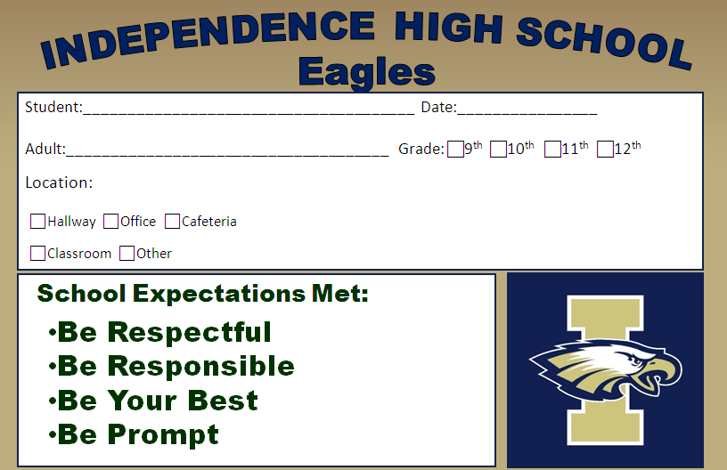

 | P  Productivity We are responsible participants in our  education. |  | R  Respect  We respect others and accept differences. |  | I  Integrity  We do the right thing even when no one else is watching |  | D  Duty  We are safe members of our school and community. |  | E  Empathy  We aim to understand the feelings of others.
Week One  Total  Initial | Teacher Initial | Date | Teacher Initial | Date | Teacher Initial | Date | Teacher Initial | Date | Teacher Initial | Date
Week Two  Total  Initial | Teacher Initial | Date | Teacher Initial | Date | Teacher Initial | Date | Teacher Initial | Date | Teacher Initial | Date
*Within each students’ planner, there is a row for each week of the term. Students receive new pages for each new term.

Adapted from Florida’s PBIS Initiative (http://flpbs.fmhi.usf.edu/)

