Price | Menu Items for Madison Place Elementary
2 Tickets | Pencil from the office
3 Tickets | Hat Day Pass
3 Tickets | Slipper Day Pass
3 Tickets | Bring a stuffed animal to school for a day
3 Tickets | Take your shoes off in class for a day
5 Tickets | Picture of you and two friends on the Kiosk
5 Tickets | Use your teacher’s chair for one day
5 Tickets | Move your desk to a different location in your classroom for one day
5 Tickets | Read aloud a book in class of your choice
5 Tickets | Assist teacher of your choice for 15 minutes
10 Tickets | 15 minutes of extra reading time as agreed upon with teacher
10 Tickets | 15 minutes of extra computer time as agreed upon with teacher
10 Tickets | 15 minutes of drawing time as agreed upon with teacher
10 Tickets | Eat lunch in the classroom with a friend
10 Tickets | Free homework pass on a daily assignment
10 Tickets | Eat lunch with a specialist teacher of your choice
10 Tickets | Use Dr. Stevenson’s chair for one day
10 Tickets | Eat chips and dip with Miss Brownlee during lunch
10 Tickets | Dance in the music room with 2 friends and Mrs. Bruning
12 Tickets | Serve as a workroom assistant for 20 minutes
12 Tickets | Serve as a custodial assistant for 20 minutes
12 Tickets | Serve as a lunchroom assistant for 20 minutes
12 Tickets | Shoot baskets in gym with Mrs. Brenner for 20 minutes
12 Tickets | Design a bulletin board with Mrs. Lantman for 20 minutes
12 Tickets | Use headphones/I-Pod during computer class
15 Tickets | Cook with Miss Wichert after school
15 Tickets | Eat a snack and play a board game with Miss Eaton
15 Tickets | Play a game of your choice with Mrs. Griffin
15 Tickets | Serve as a library clerk with Mrs. Payton for 20 minutes
30 Tickets | Have Mr. Wright as your own personal assistant for one hour
30 Tickets | Shave Mr. Buss’ head with appropriate design of your choice
30 Tickets | Enjoy a free McDonald’s lunch with Dr. Stevenson
30 Tickets | 15 minute extra recess for your entire class

TICKET MENU EMERSON ELEMENTARY
# of Tickets | Item
5 | wear slippers
5 | shut down library computers at the end of the day
5 | earn bookmarks for your class
5 | listen to music while working
5 | homework pass
5 | GOTCHA GREETING *e-mail or phone call to parent
5 | library scout on designated library day
5 | choose a class job for the day
5 | draw on board while teacher reads a story
5 | pencil from the office
5 | tell a joke to the students while in the gym in the morning with Mrs. Buchanan
10 | sing a song to the students while in the gym in the morning with Mrs. Buchanan
10 | wear hat
10 | 10 minutes of "Bearcat Boogie" for the class
10 | use the TEACHER'S CHAIR for the day
10 | read 10 minutes to an adult in the building
10 | EMERSON IDOL! Showcase student picture in the entryway.
10 | custodian helper
10 | free serving of milk or juice
10 | positive post card home
10 | eat lunch with your class outside
10 | earn a ribbon
25 | lunch with the teacher
25 | design a bookmark
25 | counselor assistant
25 | "Monet for the day" sidewalk art showcased at school entrance
25 | student moves desk anywhere in their class for the day
25 | rent the principal's chair for a day
25 | library assistant
25 | pal pic
25 | play a board game with a friend instead of outside recess
25 | morning MC with Mrs. Buchanan
50 | lunch with the Mrs. Evans
50 | lead exercises in p.e.
50 | walking field trip for class (30 minutes maximum)
50 | get a gift wrapped pack
50 | lunch with Mr. Clark
50 | guest reader for the class

TICKET MENU SHAWNEE MIDDLE SCHOOL
 |  | COST
Pass to the front of the lunch line |  | 5
Mystery Pack |  | 5
Appear in a school video about PACK |  | 10
Assist with morning announcements over the PA system |  | 10
Frisbee, hula hoop, jump rope, paddleball, or sidewalk chalk |  | 10
Lunch with a teacher or principal |  | 10
Video store or movie theatre coupon |  | 10
Announce the players at a sporting event |  | 15
Assist on the scoreboard |  | 15
Be on the sidelines of a sporting event |  | 15
Lunch with a friend in a classroom (with the teacher) |  | 15
Office aide for a period |  | 15
Free pass to a school event |  | 20
Free pass to the dance plus one concession item |  | 20
Music, Art, or Sport Instruction from a teacher or coach |  | 20
Lunch outdoors with three friends |  | 25
Play Wii during recess with a friend |  | 30
Watch a video with a friend instead of recess |  | 30
VIP Lunch with three friends |  | 35
Dress as the school mascot during a game |  | 50
Duct tape the principal to the wall |  | 5000
Weatherford High School

Ticket Purchases

Picture in the paper
Name in lights
Tardy removal
Homework pass
Gift cards---gas, I-Tunes, Walmart
Free lunch
Candy bags
Early release
Use of I-Pods
Wear hats or sunglasses
Off-campus lunch (freshmen/sophomores)
Excused from FF or SS
Buy DP, coffee, food from us
Free activity pass
Free yearbook
Calculator
Pencils
Notebooks
Highlighter
Free vending pass
Designated parking space
Pizza delivery
Movie pass
DVD rental
Preferential seating at activities
Sit at teacher’s desk/podium for the hour/day
Choose your seat for the day
Free club dues
Free dance pass
Free ala carte ticket
Disposable cameras
National Guard paraphernalia
College gear
Booster club t-shirts
WHS blanket
Valet parking
Free pack of 250 business cards
Shout-out on announcements
Karaoke at lunch
Free Concession pass
First in lunch line
Lunch with a teacher

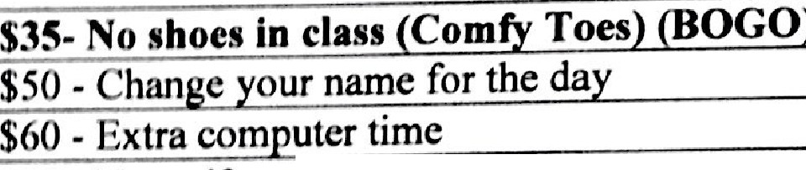
SALE ITEMS:
Prize Selections
$10 - Colorful Bracelet (Adjustable)
$IO-Animal Shape and Smiley Face Erasers
$10 - Colorful Drinking Straws
$15 - Animal Pencil Top Erasers
$25-GLOVES
$30 - Silly bands (Limited)
$30 - Stretchy Lizard Animals
$30- Ice Cream Cone Eraser/Pencil Sharpeners
$30 - Candy Color Highlighter Pens
$40 - Paper Gliders
$50 - Candy grab bags/Candy egg (Kindergarten)
$50 - Colorful Composition Notebooks (Limited)
$50 - Folders (Transformers, Cars, Smiley Face, Flowers)
(BOGO)
$50 - Star Banks (Limited)
$50 - Braided Bracelets
$50 – Matching HAT & GLOVE Set
$50 - Smelly Highlighter Pens
$50 - Pencils (Scented, Team, Smiley, Theme) (BOGO)
$50 - Mini Music Instruments/Clappers
$50 - Globe Key Chains
$55 - Flower Pencil with matching eraser
$55 - Sports Team Pencil with matching eraser
$55- Chocolate sharpener/eraser
$60 - Diamond Ring Eraser
$60 - Mini Cars
$100 - Colorful Game Cube (Rubric Cube)
$ I 00 - Learning Puzzles/Puzzle Games
$100 - Mystery Grab Bags
$100 - Small Balls
$100 - Candy (Ring Pops/Airheads)
$150 - Bendable Animals
$150 - Colorful Writing Pen Bracelets (3rd/4th)
$150 - Jewelry Bag (ring/bracelet) (K/1st/2nd)
$150- Small Stuff Animal/Heart Shaped Pillows
$200 - Medium stuffed animal
$200-Fashion Dolls
$200 - Hello Kitty Mini Bags
$250 - COLORFUL BALLS (LIMITED)
$300 – Specialty Board Games (LIMITED)
$300 - Princess Paintin2 Sets (LIMITED)

*Coupon of the Month -
No Uniform Shirt for the Day
No Shoes in Class (Comfy Toes) (BOGO- Buy One Get One Free)

**Prizes of the Month Pencils - w/o erasers Folders
COOL
PRIZES!
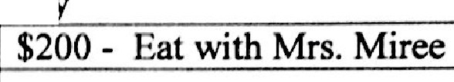
Cumberland Coupons
$75 - No uniform shirt for a da BOGO
$80 - Wear a hat in class
$90 - No homework for a night (Homework Pass)
$100 - Hel a Teacher
$150 - Eat with Mr. Cam be11
$200 - Co Anchor with Mrs. Miree on WCES for a day.

New Items
Stretchy Lizard Animals ($30) Paper Airplane Gliders ($40) Globe Key Chains ($50) Chocolate Sharpener/Eraser($55) Mini Cars ($60)
Candy (Ring Pops/Airhead) ($100) Heart Shaped Pillows ($150)
Hello Kitty Mini Bags ($200) Fashion Dolls ($200)
K i t e S (.$loo)

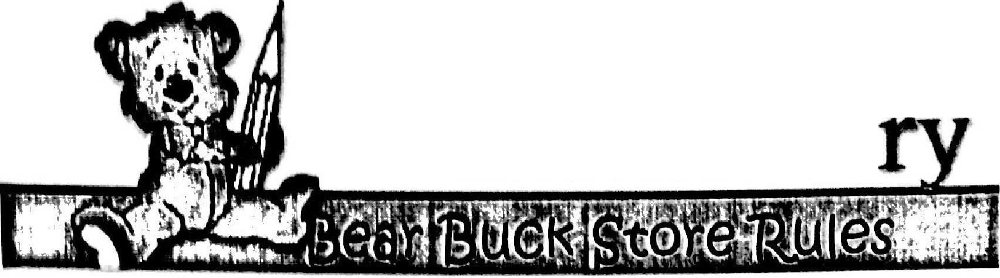
Cumberland
Elementa ...

We are so excited to have you shop with us today!
Here are few rules that you should know before today!
  - You may purchase 3 items. One large item ($100 or more), one small item (less than $100), and a coupon per shopping trip.
- ALL BUCKS WILL BE COUNTED AS $5.00!
- Bucks not used today, can be used on your next shopping trip.
- Have your orders form, when you come to the store

COOL
PRIZES!

Great
Job!

