Dear Sir or Madam,

I am writing to you on behalf of Bramble School. We are implementing a school-wide positive behavior program called Response to Instruction and Intervention for Behavior. RTI²-B is designed to teach students pro-social skills and to support behaviors consistent with a positive and safe learning environment.

In order to ensure the success of RTI²-B, it is imperative that we reward students, teachers, and staff for displaying positive behaviors that reflect a dedication to learning and citizenship. Bramble School has a very limited budget and we are asking for monetary and/or product donations that can be used as rewards for our students who display consistent positive behavior. Donations of any size are greatly appreciated and will be recognized in our monthly school news letter, in PTA and faculty meetings, and in print materials created to promote RTI²-B in our school.

Thank you for your time and consideration. We appreciate your dedication to the education of our youth. Your generosity is greatly appreciated. If you have any questions or would like know more about our PBIS program, please feel free to contact the school at ________________________.

Sincerely,

RTI²-B Team Lead
________________________

(put on school letterhead)

(insert date)

Dear Business Owner/Manager,

We know you support education and are asking for your collaboration in creating better employees for you to hire in the future by creating a climate of respecting responsibilities and respecting relationships in our children. Here are some specifics about our school:

First, at (insert the name of your school here), we are focusing on three behavioral expectations: Respecting Self, Respecting Others, and Respecting Property. This is part of a systems change project we are supporting in an effort to increase time on task and improving academic achievement. We would like you to inform your employees of our school’s expectations and ask them to notice students who exemplify these skills when visiting your establishment and give specific feedback to the students they see by saying things like: “I like the way you showed respect for others by walking politely in the store aisles.” This will label appropriate behavior and help children make the connection to generalize what we are teaching at school in the community. We have included on the next page some paper acknowledgements that you can hand out identifying these behaviors when you see them. We call these acknowledgements “gotchas” and we appreciate your support of this effort. We feel that labeling appropriate behavior will increase that behavior in all children in all areas of their lives. The children will bring these gotchas back to school for points.

Second, we would like to invite you to attend any functions at the school. Our school website is (insert website here) and we will post any evening performances, PTO/PTA meetings, carnivals, or other events on this website. Please come dressed in your uniform or wearing your employee name tag as a way to advertise your business. We feel this will not only allow you to advertise your business but help children see the value and importance of their education when it is supported by the entire community. We know the greatest gift we can give anyone is time and to build a relationship. Research indicates there are four things that are most important in building a relationship: eye contact, talking, using the child’s name, and touching (high fives).

Third, we are asking for any donations you may be able to provide in the way of goods or services. These donations could include: letters giving parents of students who are caught exhibiting excellent behavior a discount on your services, tangible prizes for educators or students, offers of allowing a child to serve as an apprentice in your store, trial memberships to your organization, samples of your services, etc. We are including a tax deduction letter you may use for tax purposes on this deduction. We want this to be a symbiotic relationship. We know that if you support us by providing these contributions, it will bring business to your establishment from the parents of the students we are working with, in our school.

We thank you in advance of your support of (insert name of school). We know the students of today will become the employees of tomorrow. Your support now will reap huge benefits in the future.

Educationally yours,

4

(insert your name here)

(insert letterhead here)

RE: Tax Deduction Date: (insert date here)
Dear ,

On behalf of [insert your school name here], We would like to thank you for your generous donation of

Your contribution makes it possible for us to encourage students to exhibit appropriate behaviors and support the parents and teachers who work to make this possible.
Since its inception in 1995, Positive Behavior Support has decreased office discipline referrals, increased academic scores and attendance, and increased overall satisfaction in schools. In [part or current year] we have begun the task of teaching, modeling, practicing and labeling appropriate behavioral expectations for all of the children at (insert school name here). Children collect points for being “caught” exhibiting behavior and can use these points to purchase items like:
- Time playing tennis with a preferred adult

- Pizza for the whole family

- Renting a movie for the whole family

- Paddle boating with a family member

- Etc.

This is only possible because of thoughtful contributions from people like you.

In [current or coming year], we plan to increase appropriate behavior and reward those children who exhibit these behaviors. We also want to reward the parents and educators who support this behavior. As you know, the cost of education does not go away. We hope for your continued support in the future.
The estimated value of goods or services provided in return for your donation were $ . Please keep this written acknowledgment of your donation for your tax records.
Once again thank you for your generous donation. Sincerely,
Signature

5

This business wants children to be:

Respectful of Self
o Represent yourself by maintaining good character and values
o Ask permission to touch breakable items
Respectful of Others
o Leave unpaid merchandise in the store
o Speak in a voice that can only be heard in a 6-inch radius
Respectful of Property
o Report any unsafe issues to an employee
o Leave store cleaner than you found it

6

Sample gotchas to give out:

I was caught in a Community Sponsor’s place of business exhibiting excellent behavior. Here’s what I did:  - Respecting Self  - Respecting Others  - Respecting Property  I was caught in this establishment:  Signed by: Date: | I was caught in a Community Sponsor’s place of business exhibiting excellent behavior. Here’s what I did:  - Respecting Self  - Respecting Others  - Respecting Property  I was caught in this establishment:  Signed by: Date:
I was caught in a Community Sponsor’s place of business exhibiting excellent behavior. Here’s what I did:  - Respecting Self  - Respecting Others  - Respecting Property | I was caught in a Community Sponsor’s place of business exhibiting excellent behavior. Here’s what I did:  - Respecting Self  - Respecting Others  - Respecting Property
I was caught in this establishment: | I was caught in this establishment:
Signed by: | Signed by:
Date: | Date:

7

Hut.
Some ideas of ways you could contribute:
Jiffy Cube
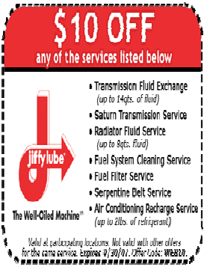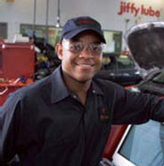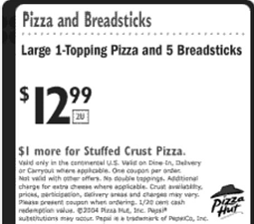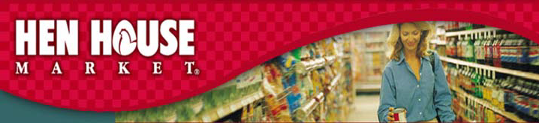
Dear Parents,
We at Jiffy Lube commend you on sending your child to school with such great mentoring that they earned a gotcha for having excellent behavior.
Please bring in the attached coupon for $10 off your next oil change or Jiffy Lube Service.
Dear Parents,
Your child’sname wasdrawn from a large group of students who received “gotchas” for exhibiting excellent behavior. We at Hyper Mart Super Groceries would like to thank you for sending such a great child to school. It would be our honor if you would have your child come to Hen House this Saturday at 8:00 a.m.
Your child will spend the day learning what it takes to run a grocery store from accounting, stocking, bagging, registers, announcements, coupons, etc. They will personally spend the day with me and lunch will be provided in our deli.
You may pick up your child at 4:00 p.m.
The Apprentice .

HYPER MART SUPER GROCERIES
Pizza House
Dear Parents,
Congratulations. Your child earned a “gotcha” for exhibiting excellent behavior at school.
We would like to honor your family with one free one topping medium pizza for free.
Bring this coupon in to pick up or dine in your local Pizza

Jiffy Cube
Jiffy Lube

8

Other ideas:

- one month membership to your gym services
- free neck massage
- discount on manicure
- free plant with purchase
- advertising tangibles (example: “I am Loved” pins from Helzburg Diamonds)
- free T-shirt with your logo on it
- discount on food items
- free drink or snack item
- free video rental or buy one get one free
- tour of your place of business
- sample of your services (personal pan size version)
- snacks for a class
- sample foods from your establishment for a family math night
- pens, pencils, stadium cushions, tablets with your business logo on them
- free training in your specialization
- opportunity to call in requests to your radio station
- sponsor activities financially or with incentives

Anything you can think of that would be a “two for” 1) You will gain some free advertising and 2) One of our children or their parents or their teacher s will earn a discount or gift for supporting children in the schools.

In return for your support we will:

- list your business’ name in our school newsletters
- lay out flyers for your business at our open house nights on a community supporters table
- encourage our parents and employees to support your place of business

9

