EXAMPLE SCHOOL
Positive Behavioral interventions & Supports (PBIS) | 2016-2017
Annual Summary

How are we implementing PBIS at our school in Tier I? | 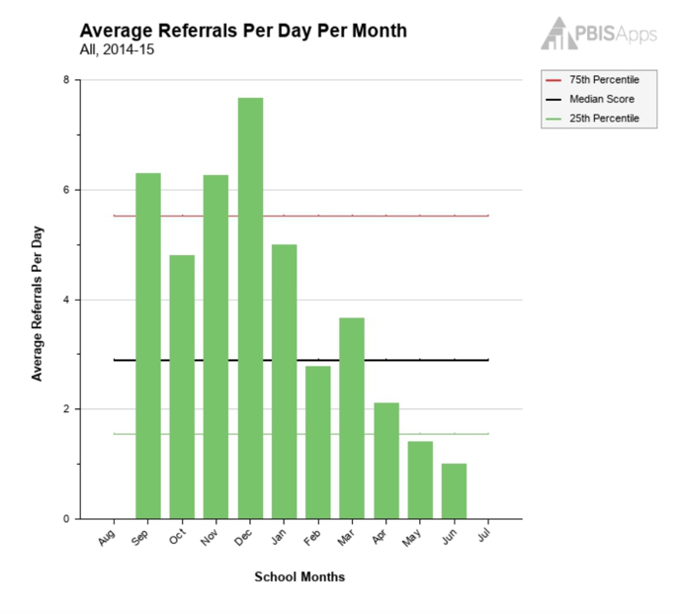  Tier II Interventions Success Rate  Check-In/Check-Out 80%  Social Skills 30%  Anger Management 33%  Homework Club 71%
The Tiered Fidelity Inventory (our PBIS assessment) indicates that we are implementing all tiers of PBIS at or above the benchmark. We have identified the items from each tier that we want to improve, and we have included them in our Action Plan at the end of this report. We want to include family members on our PBIS Tier I team.

What is our Office Discipline Referral rate?
Our referral rate was above the nation average the first part of the year. After we retaught expectations and were consistent with our acknowledgement and consequence systems, there was a decline in the average referrals per day. We ended the year at well below the national average for our size and level of school. We will celebrate this accomplishment with our students at our year end assembly on June 1st at 2:00 pm in the gym.
How is our attendance?
Last Year: 83.5% This Year: 93.5%

Our Attendance Initiative is producing excellent results and we are working to continue to improve our attendance. Thanks to all our families for the help with this wonderful progress.

How effective are our Tier II Interventions?
We provide interventions for students needing additional support. Our interventions of Check-In/Check-Out, Social Skills Groups, and Homework Club were successful this year. We have items in our Action Plan to improve the outcomes of the Anger Management group for next year.

Example School, 1642 Shasta Way, Cascade, OR 97400 541-001-1110

How effective are our Tier III Interventions?

We provide Tier III Interventions for students needing individualized supports. Our Behavior Support Plans and the Attendance Initiative Intervention have been successful. We want to improve the outcomes of our Wraparound program which is included in our Action Plan.

Intervention | # of Students | # of Students Meeting Goal | % Successful
Behavior Support Plans | 5 | 4 | 80%
Wraparound | 3 | 1 | 33%
Attendance Initiative | 2 | 2 | 100%

How are we implementing all Tiers of PBIS at our school?

The graphs below show that we are above the benchmark (70%) in almost all areas. We are excited about our PBIS implementation and our Action Plan includes steps to help us sustain our program and continue to improve.

Our Action Plan for 2017-18:  - We will expand our PBIS Team to include more representative teaching staff and will also include a family member. Our Tier I team will meet monthly, the third Wednesday of every month, alternating before and after school.  - Change the format of the Anger Management group to assess the student needs and focus on specific social/emotional skills.  - Review our Wraparound Intervention and plan ways for the community partners to have more involvement.  - Continue to sustain our strong PBIS implementation across all tiers, with our goal of helping all children to be successful. | Contact Us  Please call or email us with your questions or comments.  Example School PBIS Team  Joan Smith, Facilitator  (999)999-0123  email@example.com
Example School, 1642 Shasta Way, Cascade, OR 97400 541-001-1110

PBIS Annual Summary

Roosevelt School

Annual School Summary – Tier II example

How do students access Tier II Interventions?
Families and staff members can complete a request for assistance indicating the student’s need for additional supports. Students are generally identified through major office discipline referrals, attendance issues, difficulty in school and/or student referral. The Tier II team reviews the referrals biweekly and makes decisions about which Tier II Intervention would best fit the student. Parent permission is given prior to any student beginning a Tier II or Tier III intervention.

What is the status of PBIS implementation?
The TFI indicates that we are implementing both Tier I and Tier II with Fidelity. Within the care features, we are strong in all areas, except for Tier II Interventions.

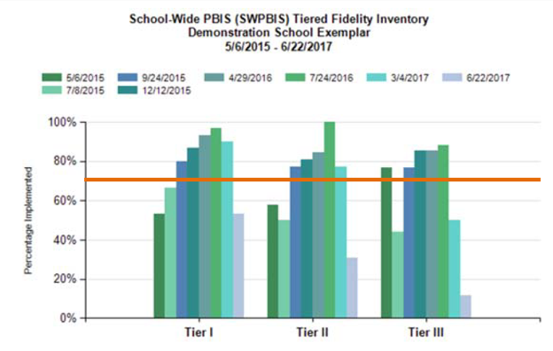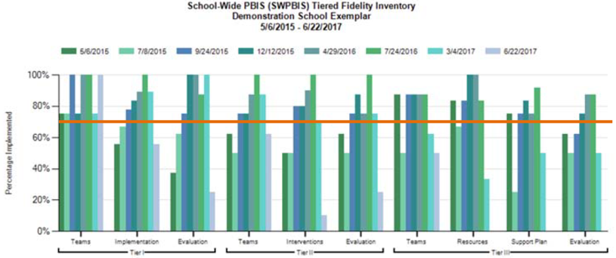

How effective are our Tier II Interventions?
Intervention | # of Students | # of Students Meeting Goal | % Successful
Check-In/Check-Out | 25 | 20 | 80%
Social Skills Groups | 30 | 27 | 90%
Anger Management | 15 | 5 | 33%

Action Plan for Next School Year:
- Increase our number of students in CICO by adding another CICO Mentor
- Change the format of the Anger Management group to assess the student needs and focus on specific social/emotional skills.
- Consider adding a recess intervention: Recess Academy for students needing the intervention.

