RTI²-B School Team Workbook
Tier III Training Session 4
School:
District:
Date:
Participants:
Activity #1: ABC Data Collection – Video
As you watch the video, take ABC data using the ABC Recording Form. Write down times for each occurrence of the problem behavior, and check off the antecedents and consequences you observe.

Observer: Tier 3 Training Student: Joseph
Setting: Science Date: ____________ Time: __________
# | Time | Activity | Antecedent | Behavior | Consequence
1 |  | ☐Large group  instruction  ☐Small group work  ☐Independent work  ☐Unstructured time | ☐Task  ☐Unstructured time  ☐Reprimand  ☐Structured, nonacademic  activities  ☐Transitions  ☐Isolated | ☐Behavior | Adult Attention  Peer Attention  Task/Activity/Request  Tangible Items  Sensory Stimulation | Obtain  ☐  ☐  ☐  ☐  ☐ | Avoid  ☐  ☐  ☐  ☐  ☐
2 |  | ☐Large group  instruction  ☐Small group work  ☐Independent work  ☐Unstructured time | ☐Task  ☐Unstructured time  ☐Reprimand  ☐Structured, nonacademic  activities  ☐Transitions  ☐Isolated | ☐Behavior | Adult Attention  Peer Attention  Task/Activity/Request  Tangible Items  Sensory Stimulation | ☐  ☐  ☐  ☐  ☐ | ☐  ☐  ☐  ☐  ☐
3 |  | ☐Large group  instruction  ☐Small group work  ☐Independent work  ☐Unstructured time | ☐Task  ☐Unstructured time  ☐Reprimand  ☐Structured, nonacademic  activities  ☐Transitions  ☐Isolated | ☐Behavior | Adult Attention  Peer Attention  Task/Activity/Request  Tangible Items  Sensory Stimulation | ☐  ☐  ☐  ☐  ☐ | ☐  ☐  ☐  ☐  ☐
Behavior Definition:
Inappropriate Commenting – Verbal comments/statements directed at peers or adults that are rude or hurtful in nature. Examples include: mimicking other students and interrupting others when they’re talking.

Activity #2: Tally ABC Results
Look at the ABC data you collected. Tally the activities, antecedents, and consequences. Then calculate ratios for all three.

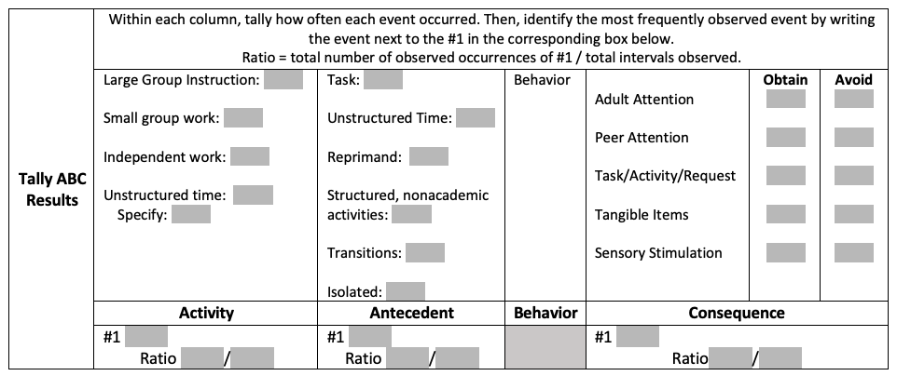
Activity #3: Function Matrix
Use the Case Study Example to review the ABC Data and Interviews and practice completing the Function Matrix. As a team, discuss what function the student’s problem behavior might serve by reviewing the Function Matrix.

 | Obtain | Avoid
Tangible Item
Task or Activity
Social Attention
Sensory/Stimulation

Session 4 Homework Checklist and Action Plan:
Action Item: | Who? | By When? | Notes:

