The first page should be used by the interviewer to record student responses. Be sure to note both verbal and gestural responses. Present pages 2-5 to the student in a format consistent with instructional tools or assessments (electronically, printed and laminated, cut by section and attached on a ring, etc.).

Student Information:
Student Name: | Age and Grade:
Interviewer: | Date
 | Click here to enter

Questions
What is your favorite class at school?
What do you like about class?

What are some things you do very well?
When do you have the most difficulty at school? or What things are hard for you to do at school?
What is it about _____ that you find to be the most difficult? or Why is ______hard?

Preference Assessment

Use the following list to determine possible rewards to incorporate into the BSP.
Attention  ☐Playtime with friends  ☐Read with friends  ☐Watch a music video with friends | Tangible/Activity  ☐Special snack  ☐Sticker  ☐technology time | Other  ☐Break space with sensory activities and or items  ☐Headphone or music time  ☐Play with squishy ball
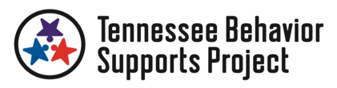
Summary Statement: (To be completed by the interviewer)
Identify the hypothesis that will be used to build a behavior support plan. Mark your confidence in the hypothesis statement.
Antecedent(s): | Problem Behavior: | Consequences:
Not Real Sure 100%Sure
☐1 ☐2 ☐3 ☐4 ☐5 ☐6

Present the student with the visual options for each question. Use your knowledge of the student to determine if you need to cover answer options and present only two at a time. Multiple rounds of questioning can be done to determine the final response for each question. Give one verbal directive (to verbally respond or point), provide wait time (use knowledge of student to determine length), and give no more than one additional verbal or gestural prompt.

What is your favorite class?

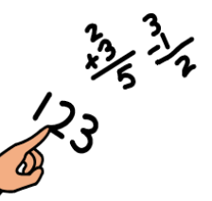
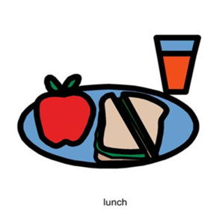

Math
Lunch
Reading

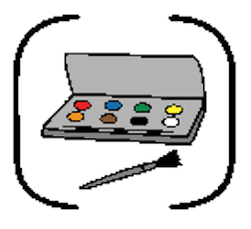
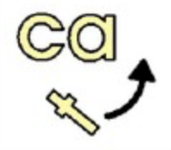
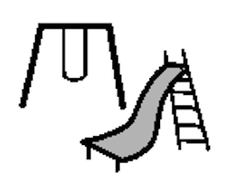

Word Work
Art
Recess

Why do you like that class?

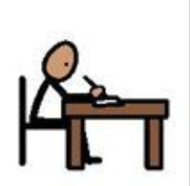
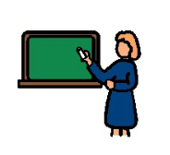
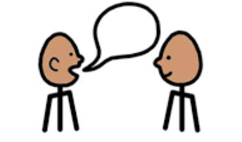

Work
Teacher
Being With My Friends

What are some things you are good at?

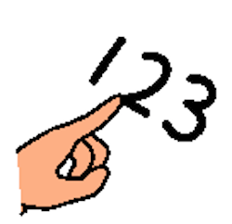

Writing
Counting
Reading

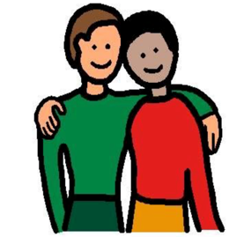
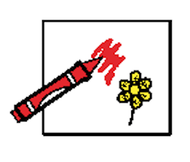
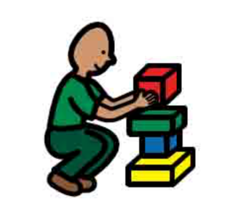

Building Blocks
Coloring
Being a Friend

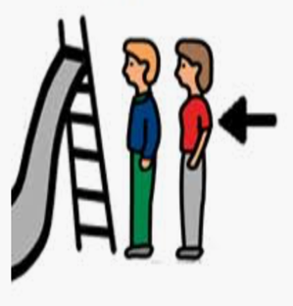
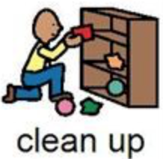
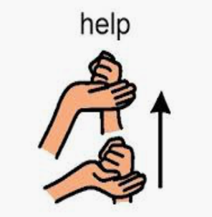

Taking Turns
Cleaning Up
Asking for Help

What class do you not like?

Lunch
Math
Reading

Art
Word Work
Recess

Why do you like that class?

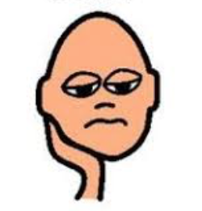
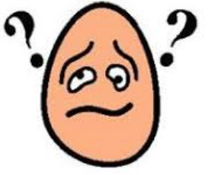
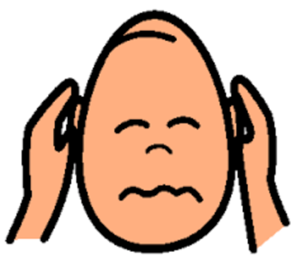

Boring
Hard
Too Loud

Attention/Activity
Sensory

Tangible
What do you like to work for?

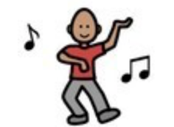
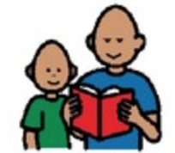
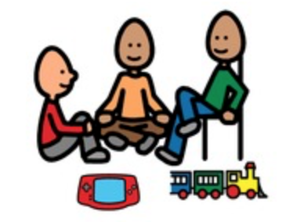

Music Video
Read with Friends
Playtime with Friends

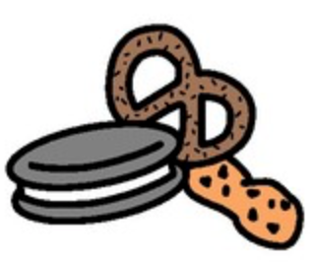
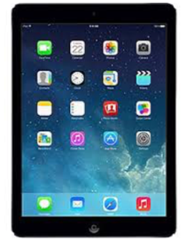
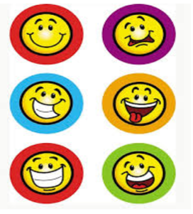

iPad
Stickers
Snack

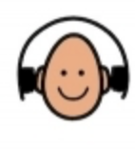
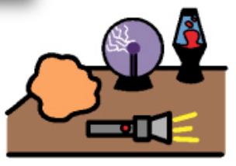

Squishy Ball
Headphones
Break Space

