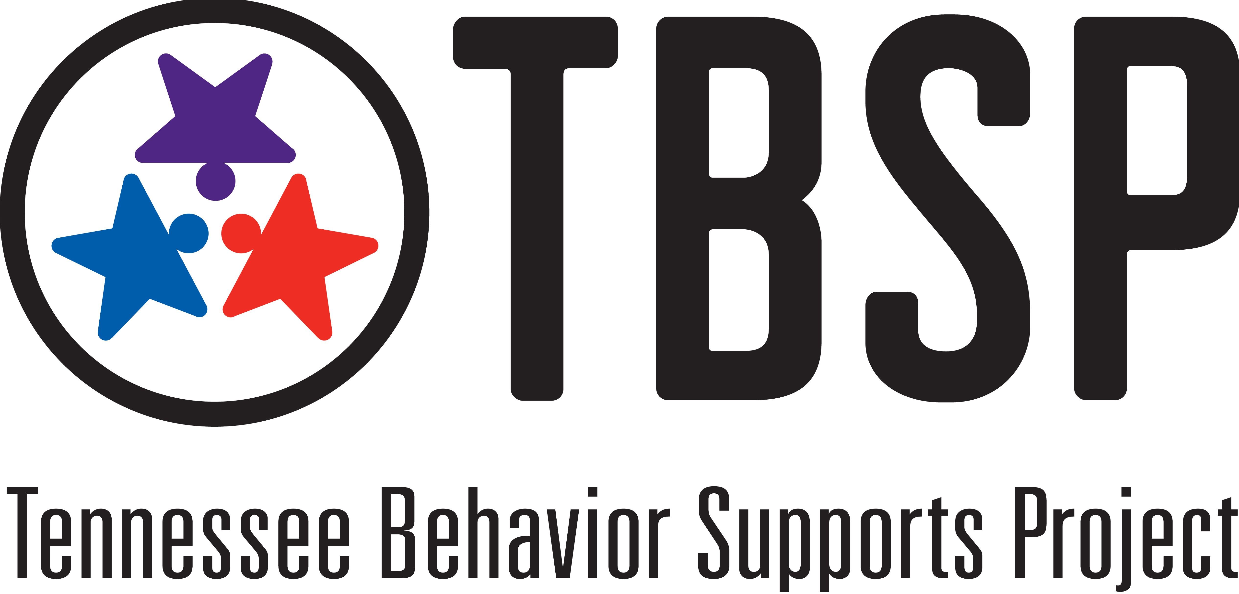
Functions of a District RTI²-B Coach
- Qualifications

The District RTI²-B Coach coordinates and leads school teams through the process of establishing and implementing RTI²-B. The District RTI²-B Coach typically has both building and district level roles and responsibilities.
- Specific knowledge and skills
  - essential features of school-wide RTI²-B
  - data collection systems, data-based decision making, fluency with data collection tools
  - monitoring progress
  - coaching competencies (e.g., establishing and maintaining positive relationships, communicating effectively, facilitating team processes)
- Ability to support three or more schools
- Experience developing, coordinating, and facilitating staff development activities
- Other qualifications deemed necessary

2) Coordination
- Attend RTI²-B District Leadership Team Meetings
- Facilitate completion and monitoring of a District Leadership Team Self-Assessment and Action Plan
- Coordinate efforts with District Coordinator
- Communicate with District Leadership Team and Tennessee Behavior Supports Project liaisons around training, technical assistance and other supports needed to implement RTI²-B.

3) Evaluation
- Facilitate establishment of data collection systems for behavior outcomes and fidelity of RTI²-B implementation
- Work with Team Leads to collect and analyze data for problem solving, decision-making, and action planning:
  - RTI²-B implementation process data; TFI and PIRs
  - Student outcome data; discipline and academic
- Aggregate data district-wide
- Use data for decision-making with Team Leads, Administrators, and the District Leadership Team

4) Technical Assistance
Provide technical assistance to building teams regarding:
- Readiness for implementation
- Tier I implementation (data-based decision making, meeting schedules, communication with staff, teaching and acknowledgment systems, new team orientation, school board presentations, implementation manual)
- Consultation on integration of classroom management practices in Tier I

5) Training
- Assess school training needs
- Work with District Leadership Team to determine district training plan
- Actively participate in district RTI²-B trainings
- Participate in district meetings for all RTI²-B Coaches and Team Leads
- Participate in other opportunities provided to support implementation
- Develop internal training capacity (e.g., present with TBSP at District Team Lead Meetings and Refresher Trainings)

