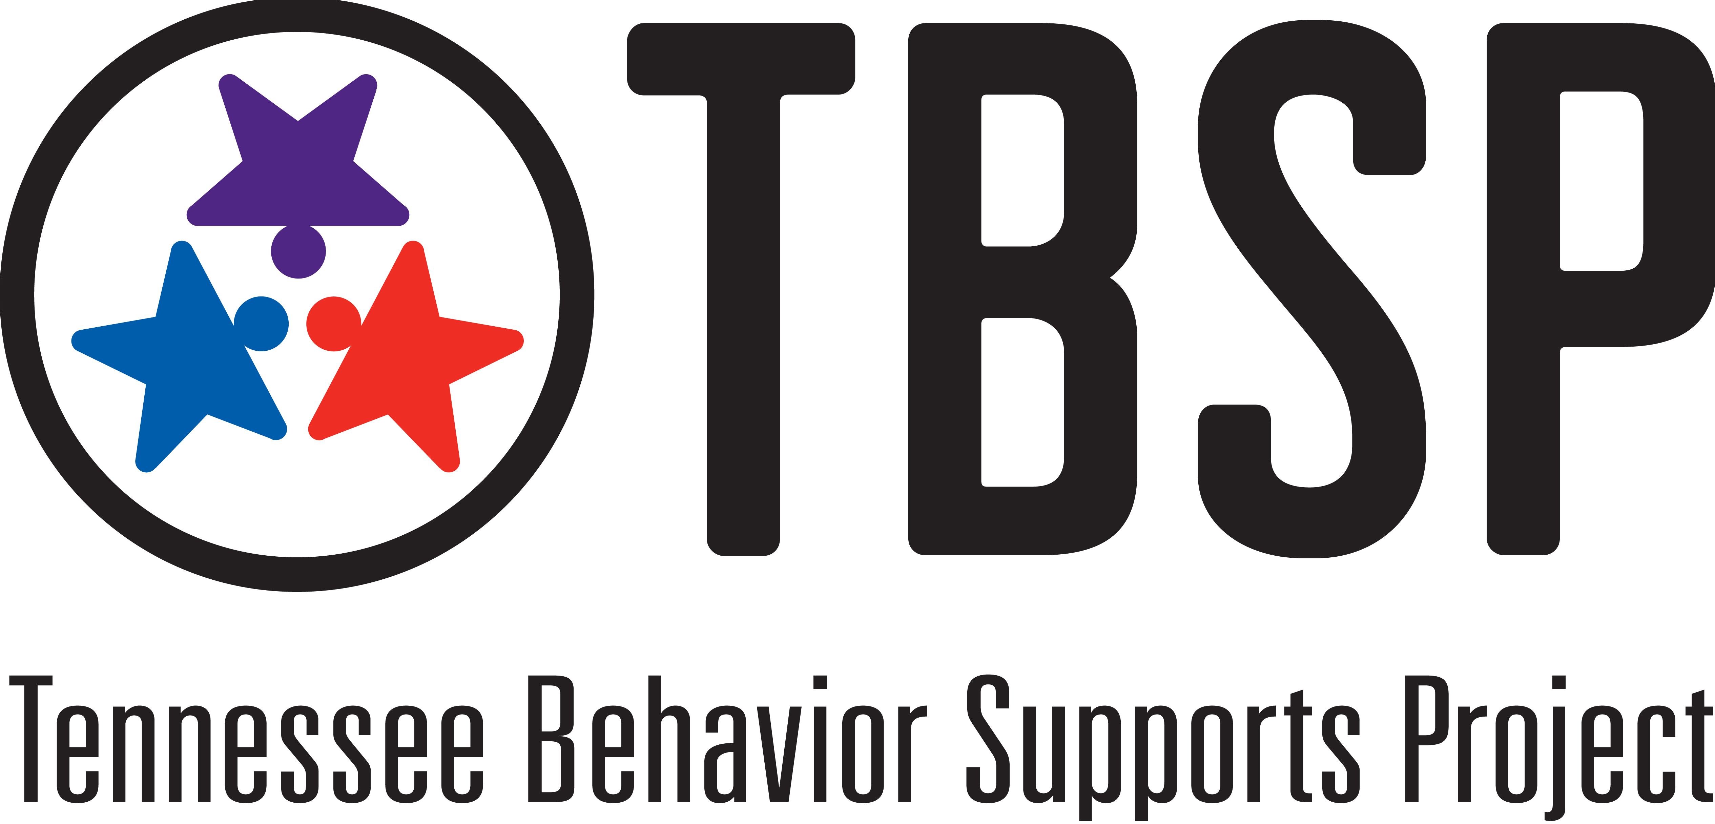
RTI²-B District Coordinator Roles and Responsibilities

A RTI²-B District Coordinator leads:

The District Leadership Team process:
- Identifying appropriate district‐level personnel to serve on the District Leadership Team
- Scheduling and assisting the District Leadership Team with the preparation of meetings
- Communicating updates on schools to the District Leadership Team
- Working with new administrators of existing RTI²-B schools to ensure continued implementation

Funding for RTI²-B related activities. Examples of this include:
- Working with other district‐level personnel to identify portions of the district budget that may be allocated to RTI²-B related activities (such as training, supporting schools, supporting professional development, etc.)
- Working to obtain outside funding for RTI²-B related activities when district financial support is insufficient. (Examples of this include writing grants, working with community sponsors, working with families, etc.)

Visibility/Political support in their district. Examples of this include:
- Updating the Superintendent and RTI²-B District Leadership Team on the progress and outcomes of RTI²-B
- Delivering presentations/materials to school board members, administrators, community partners, local media, and other groups/organizations as necessary to educate and inform them of RTI²-B activities & outcomes

Training schedules and determining readiness for new and existing RTI²-B schools. This involves:
- Identifying new schools for RTI²-B implementation
- Identifying existing schools in need of re‐training, booster, or Tier II or III training

Working with school teams to prepare for training. This includes helping teams establish buy‐in, helping teams obtain necessary data, and ensuring pre‐training activities are complete and accurate.
- Supporting readiness activities for new schools and submitting the paperwork to TBSP
- Notifying schools of their registration, location, and times of RTI²-B workshops
- Attending and participating in all RTI²-B workshops for new teams
- Supporting the district’s coaching network, identifying training needs, assisting with schools completing fidelity measures, assisting with universal behavior screeners, and performing site visits as needed

Facilitating data and the evaluation process:
- Support coaching networks understanding the RTI²-B evaluation requirements
- Working with coaches to ensure the validity of their evaluation data
- Monitoring completion of RTI²-B schools’ evaluation activities
- Reviewing and distributing evaluation results The results should be shared with district personnel, coaches, schools, parents and other groups as appropriate at least once each year
- Applying the evaluation results so they are used to identify next steps and allocate resources for the next school year

