Implementation Snapshot
Evaluation Feature: Data-Based Decision Making (1.13)
What is it?
Tier I team reviews and uses discipline data and academic outcome data (e.g., Curriculum-Based Measures, state tests) at least monthly for decision-making.
Scoring Criteria:  0 = No process/protocol exists, or data are reviewed but not used  1 = Data reviewed and used for decision-making, but less than monthly  2 = Team reviews discipline data and uses data for decision-making at least monthly. If data indicate an academic or behavior problem, an action plan is developed to enhance or modify Tier I supports | Possible Data Sources/Implementation Products  - Data decision rules  - Staff professional development calendar  - Tier I Implementation Manual  - Team meeting minutes
Supporting Implementation
Role of District Coordinator:  - Work with administrators and coaches to access the necessary data for teams to make data-based decisions  - Coordinate with IT to ensure databases allow teams to input and analyze the necessary data  - Connect administrators and coaches with resources to assist teams with data-based decisions  Role of Administrator:  - Work with District Coordinator and coaches to access resources to assist teams with data-based decisions  - Regularly review data prior to and after team meetings  - Work with data analyst to ensure he/she has ready access to data prior to and following team meetings  - Participate in discussions about data-based decision making during team meetings  Role of Coach:  - Work with District Coordinator and Administrator to identify resources to assist teams with data-based decision-making  - Receive additional support from TBSP about using data and data-based decision making, as needed  - Attend team meetings  - Help guide discussions about data-based decision making as necessary | Role of Team:  - Attend Tier I team meetings  - Attend Tier I training  - Include data discussions on team meeting agendas (Team Lead)  - Have discussions and make data-based decisions during team meetings (Data Analyst)  - Receive additional support from TBSP about using data and data-based decision making, as needed  Role of Staff:  - Participate in PD offered by the Tier I team  - Contribute and adhere to referral procedures  - Provide feedback as necessary  Role of Student, Family, Community  - Be familiar with referral procedures  - Provide feedback as necessary
Additional Resources and Research:
Practitioner Resources
- TBSP Brief: Data-Based Decision Making: Using Data to Make Informed Decisions in RTI²-B
- TBSP Brief: Evaluating Social Validity: Practice Guide for Evaluating Social Validity for RTI²-B
- TBSP Tip Sheet: Completing the Student Risk Screening Scale-Internalizing and Externalizing Behavior (SRSS-IE)
- TBSP Materials: Tier I Data Planning Form, ODR Review, Questions to Consider When Reviewing ODR Data, Sharing Data with Your School Example Presentation
- TBSP Data Webinars: Using Office Discipline Referral Data in Tier I Meetings and Helping School Leadership Teams Understand Universal Behavior Screeners and Fidelity of Implementation
- TBSP Coaches Webinar: How to Run an Effective Team Meeting Using Data
- TBSP How-To Video Series: Helping Schools Conduct Universal Behavior Screeners

Research
- Primary and Secondary Prevention of Behavior Difficulties: Developing a Data-informed Problem-solving Model to Guide Decision Making at a School-wide Level (Ervin, 2007)
- Concurrent Validity of Office Discipline Referrals and Cut Points Used in Shoolwide Positive Behavior Support (McIntosh, 2009)
- Using Systematic Screening Procedures to Identify Students Who are Nonresponsive to Primary Prevention Efforts: Integrating Academic and Behavioral Measures (Kalberg, 2010)
- Using Office Discipline Referral Data for Decision Making About Student Behavior in Elementary and Middle Schools: An Empirical Evaluation of Validity (Irvin, 2006)
- Validity of Office Discipline Referral Measures as Indices of School-Wide Behavioral Status and Effects of School-Wide Behavioral Interventions (Irvin, 2004)
- The Sustainability of Schoolwide Positive Behavior Interventions and Supports (Coffey & Horner, 2012)
- Academic Achievement and School-Wide Positive Behavior Interventions and Supports (Angus & Nelson, 2013)
- Implementing Schoolwide Positive Behavior Interventions and Supports in High Schools: Contextual Factors and Stages of Implementation (Swain-Bradway et al., 2015)

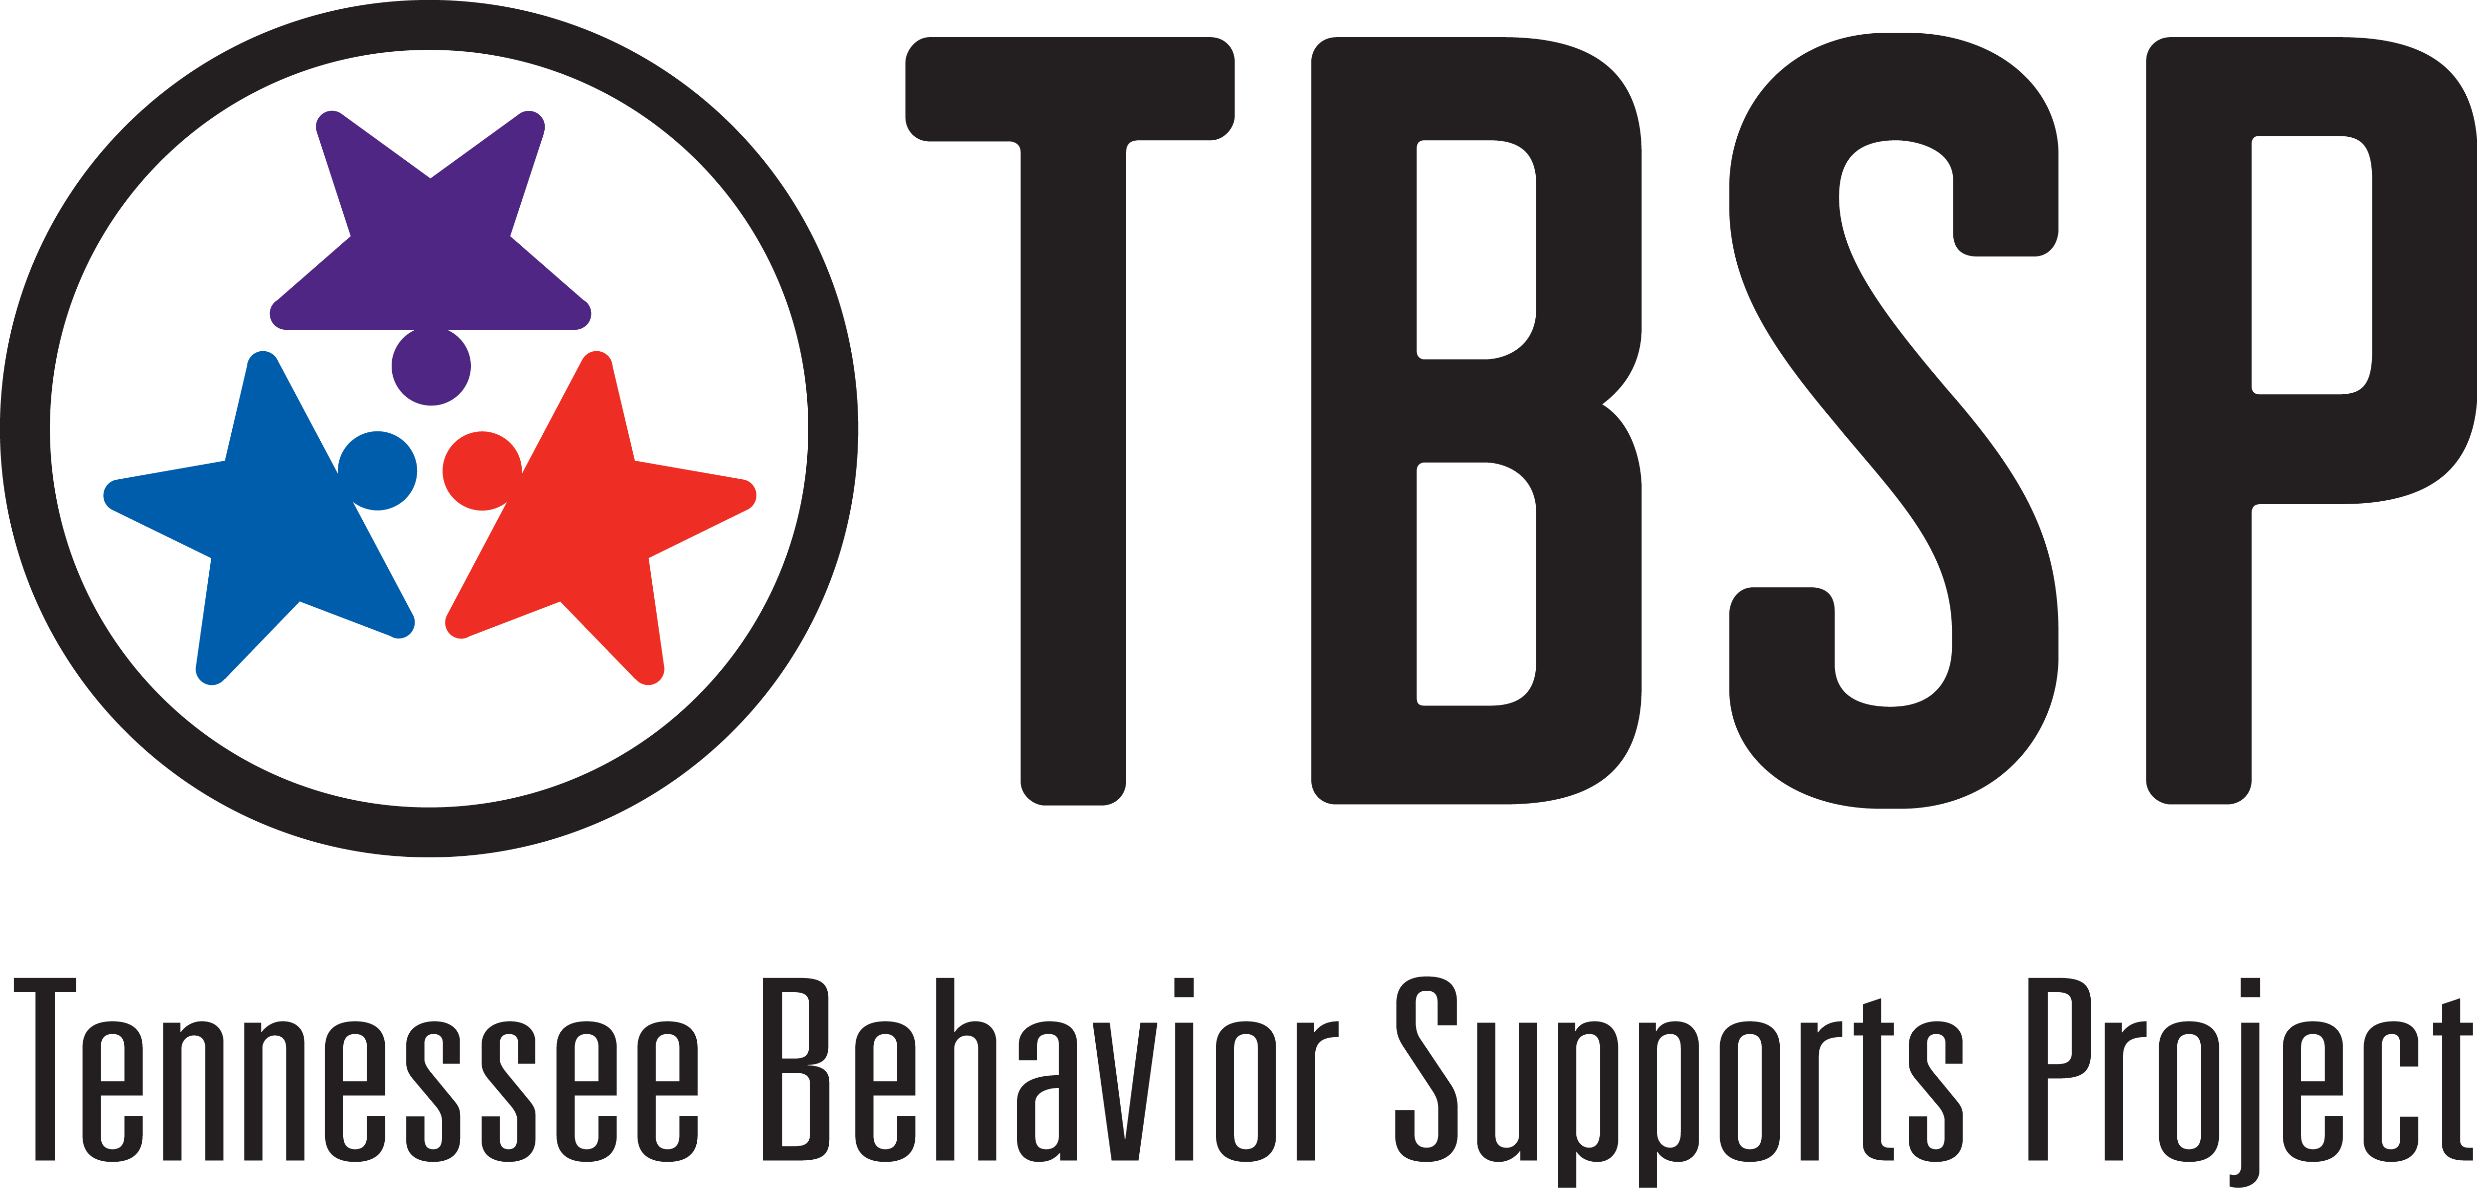
(Adapted from Susan Barrett, Maryland PBIS)

