Implementation Snapshot
Evaluation Feature: Annual Evaluation (1.15)
What is it?
Tier I team documents fidelity and effectiveness (including on academic outcomes) of Tier I practices at least annually (including year-by-year comparisons) that are shared with stakeholders (staff, families, community, district) in a usable format.
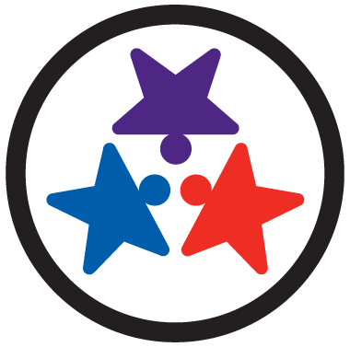  Scoring Criteria:  0 = No evaluation takes place, or evaluation occurs without data  1 = Evaluation conducted, but not annually, or outcomes are not used to shape the Tier I process and/or not shared with stakeholders  2 = Evaluation conducted at least annually, and outcomes (including academics) shared with stakeholders, with clear alterations in process based on evaluation | Possible Data Sources/Implementation Products  - Staff, student, and family surveys  - Tier I Implementation manual  - Fidelity tools  - School policy  - Student outcomes  - District reports  - School newsletters
Supporting Implementation
Role of District Coordinator:  - Share out evaluation information with district  - Work with administrators and coaches to help teams access necessary evaluation tools and data  Role of Administrator:  - Work with District Coordinator and coaches to access evaluation tools and data  - Help team communicate with staff, families, and community about evaluation information  Role of Coach:  - Work with District Coordinator and Administrator to access evaluation tools and data  - Help team analyze evaluation information and determine what information to share with staff, families, and community  - Assist team in sharing evaluation information if needed | Role of Team:  - Participate in surveys  - Participate in fidelity assessment  - Share evaluation information with staff, families, and community (Team Lead or Communicator)  - Make data-based decisions using the evaluation information (Led by Data Analyst)  Role of Staff:  - Participate in surveys  - Provide feedback as necessary  Role of Student, Family, Community  - Participate in surveys and feedback opportunities  - Provide feedback as necessary
Additional Resources and Research:
Practitioner Resources
- TBSP Resource: TFI Action Planning Form
- TBSP Training Resources: Example Data Summary Sheet, Example Annual Summary of Data

Research
- Technical Adequacy of the SWPBIS Tiered Fidelity Inventory (McIntosh, 2017)
- Within-Year Fidelity Growth of SWPBIS During Installation and Initial Implementation (Schaper, 2016)
- Academic Achievement and School-Wide Positive Behavior Interventions and Supports (Gage, Sugai & Lewis, 2013)
- Longitudinal Associations Between SWPBIS Fidelity of Implementation and Behavior and Academic Outcomes (Jerin, McIntosh, Mercer & Nese, 2018)

