Implementation Snapshot
Evaluation Feature: Team Operating Procedures (1.2)
What is it?
Tier I team meets at least monthly and has (a) regular meeting format/agenda, (b) minutes, (c) defined meeting roles, and (d) a current action plan.
Scoring Criteria:  0 = Tier I team does not use regular meeting format/agenda, minutes, defined roles, or a current action plan  1 = Tier I team has at least 2 but not all 4 features  2 = Tier I team meets at least monthly and uses regular meeting format/agenda, minutes, defined roles, AND has a current action plan | Possible Data Sources/Implementation Products  - Tier I team meeting agendas and minutes  - Tier I meeting roles descriptions  - Tier I action plan  - Tier I Implementation Manual
Supporting Implementation
Role of District Coordinator:  - Support administrators in allocating time for regular Tier I team meetings  - Ensure that coaches have time specifically allocated to attending team meetings  - Provide example agendas, meeting minute templates, and action plan templates to teams if needed  Role of Administrator:  - Ensure team members have assigned roles  - Attend Tier I team meetings  - Communicate to team members the importance of attending the Tier I team meetings on a consistent basis  - Review meeting agendas and meeting minutes prior to and following team meetings  - Allocate time for Tier I team meetings  - Work with District Coordinator to allocate time for the Tier I team to attend training  Role of Coach:  - Attend Tier I team meetings  - Attend training with Tier I team  - Review meeting agendas and meeting minutes prior to and following team meetings  - Assist team in updating action plan | Role of Team:  - Attend Tier I team meetings  - Attend Tier I training  - Assign roles to each team member  - Use a regular meeting format/agenda and meeting minutes at team meetings  - Update action plan at team meetings and at training  Role of Staff:  - Participate in PD offered by the Tier I team  - Participate in feedback opportunities provided by the Tier I team  Role of Student, Family, Community  - Become involved in Parent, Student, Teacher organization
Additional Resources and Research:
Practitioner Resources
- TBSP Materials: Example Agendas, Meeting Minutes Form, Meeting Foundations Form, Implementation Manual, Roles and Responsibilities Chart
Research
- PBIS forum in brief: Team-initiated problem solving (National Center on PBIS, 2015)
- Roundtable discussion on effective and efficient problem solving (Todd, A. W. & Cusumano, D. L., 2015)
- Dynamics of an instructional support team related to student outcomes (James E. Bolen, 2018)
- Investigating the Decision-Making of Response to Intervention (RTI) Teams Within the School Setting (Thur, S. M.,2015)
- A Pilot Study of a Problem-Solving Model for Team Decision Making (Newton, 2012)
- Positive Behavior Support: A Call for Leadership (Frey, 2008)

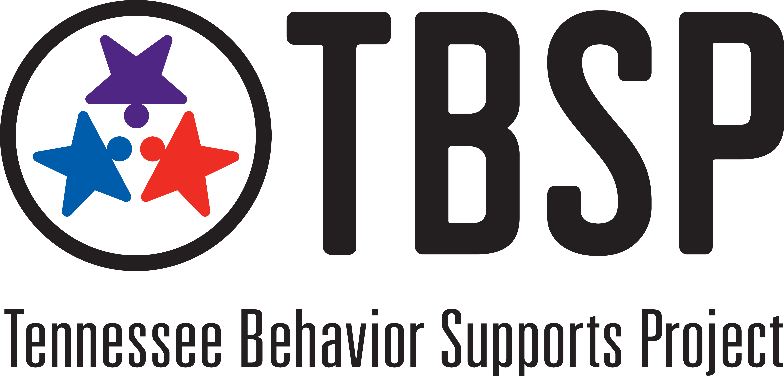
(Adapted from Susan Barrett, Maryland PBIS)

