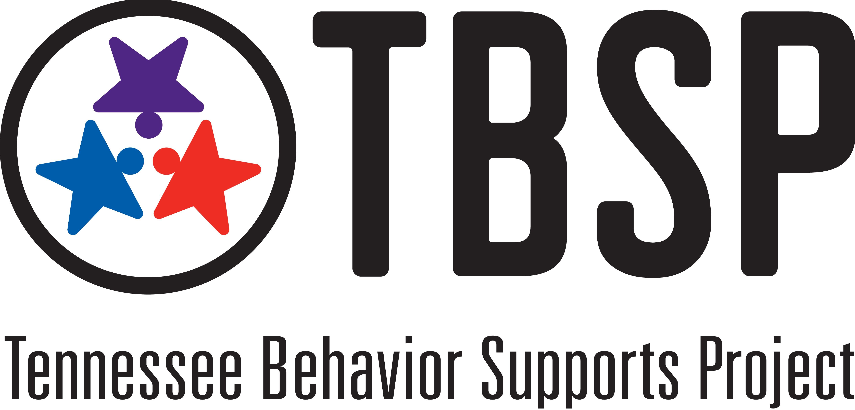
Functions of a Building-Based RTI²-B Tier I Team Lead

1) Qualifications
- Specific knowledge and skills
  - essential features of school-wide RTI²-B
  - problem-solving and school improvement processes
  - coaching competencies (e.g., establishing and maintaining positive relationships, communicating effectively, facilitating team processes)
- Works in the building full-time
- Has credibility and fosters positive relationships with other faculty/staff members
- Promotes shared decision-making and has the ability to work collaboratively with administrator/decision-makers in the building
- Demonstrates ability to work effectively in groups
- Two-year commitment to the process
- Flexibility to attend team training, network meetings and advanced training opportunities

2) Communication
- Communicate RTI²-B activities at faculty meetings
- Network with other school-based coaches, district-based team.
- Communicate with parent/parent liaison/PTA/PTO
- Share Annual Report on RTI²-B with District Leadership Team
- Communicate with District Leadership Team and Tennessee Behavior Supports Project liaisons around training, technical assistance and other supports needed to implement RTI²-B.

3) Coordination with Tier I Team members
- Facilitate monthly Tier I Team meetings
- Facilitate monitoring of development and implementation of school-wide behavior expectations, teaching, and acknowledgement practices
- Coordinate celebrations/boosters
- Facilitate completion and monitoring of Tier I Implementation Manual
- Coordinate building leadership team efforts to integrate RTI²-B into other school improvement activities

4) Evaluation
- Facilitate establishment of data collection systems
- Collect and analyze data for problem solving, decision-making and action planning:
  - RTI²-B implementation process data; TFI and PIRs
  - Student outcome data; discipline and academic
- Document success of Tier 1 interventions
- Apply for state recognition of RTI²-B efforts and outcomes

4) Technical Assistance
Provide technical assistance to building teams regarding:
- Readiness for implementation
- Tier I implementation (data-based decision making, meeting schedules, communication with staff, teaching and acknowledgment systems, new team orientation, school board presentations, implementation manual)

5) Training
- Actively participate in all district specific Team Lead Meetings
- Participate in district meetings for all RTI²-B Team Leads and in other opportunities provided to support implementation

