Tier I School Team Monthly Checklist
This checklist is designed to help teams who attended Tier I Training in the fall plan for implementation either
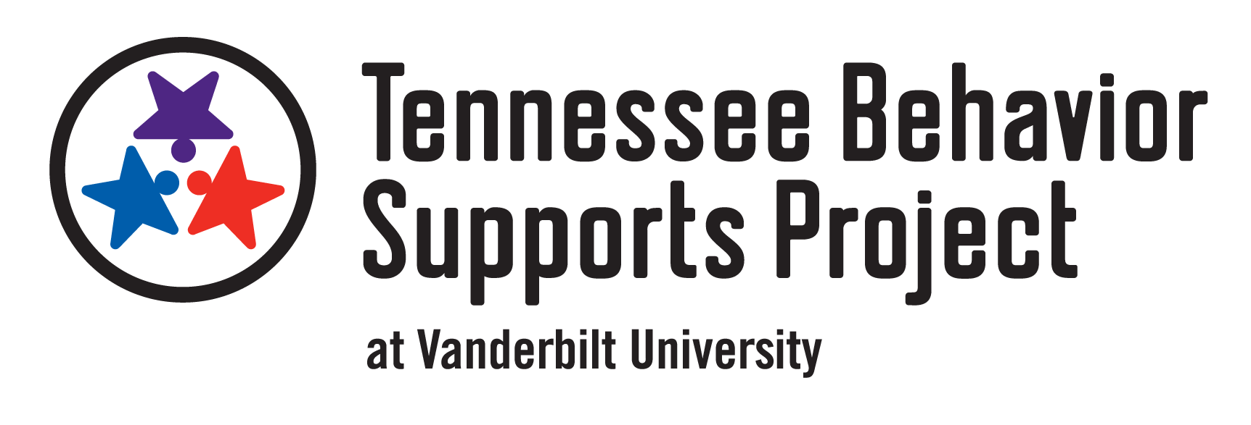
in the spring or the following school year.
Implementation Begins in Spring
During Tier I Training
- Refer to your baseline TFI data and identify areas to strengthen
- Set dates to meet monthly as a team to finalize materials before staff and student roll-out
January
- Complete activities in Implementation Manual
- Use example resources when building components
- Create subcommittees (e.g., student involvement, teaching expectations, data, acknowledgement, discipline)
- Gather input from students on the core features (e.g., focus groups, surveys, homeroom discussions)
- Gather Staff Input on all components of the plan (behavioral expectations, teaching expectations, acknowledging students, discipline process) by asking department chairs or reviewing during meetings
- Refer to your baseline TFI data and identify areas to strengthen
February
- Finalize lesson plans for teaching expected behavior, process for teaching students, changes to discipline process, and acknowledgement system
- Meet as a leadership team and individual subcommittees
- Finalize Materials to Share with Students, Staff, and Family/Community
- Behavioral expectations posters for all classrooms and all settings
- Tickets or other acknowledgements
- Ticket tip sheet (if using tickets)
- Reinforcer ideas list
- Staff presentation and roll-out plan (including Food Service, Custodial Staff, Transportation, etc.)
- Implementation manual for all staff members
- Student kick off assembly and roll-out plan
- System to teach students the behavioral expectations lesson plans in all settings
- Presentation for families
- Letter to families
- Send all finalized materials and implementation manual to your county’s TBSP Consultant or tennesseebsp@vanderbilt.edu
- Train all staff on the Tier I plan
- Begin Tier I Implementation
- For high schools, provide additional support to Freshmen
March
- Meet as a leadership team and individual subcommittees
- Review Tier I data (e.g., attendance, behavior, course performance)
- Reteach expectations after spring break
- Continue acknowledgement system for students and staff
April
- Meet as a leadership team and individual subcommittees
- Review Tier I data (e.g., attendance, behavior, course performance)
- Continue acknowledgement system for students and staff
May
- Meet as a leadership team and individual subcommittees
- Review Tier I data (e.g., attendance, behavior, course performance)
- Continue acknowledgement system for students and staff
- Use student and staff input to plan changes for next year

Implementation Begins in Fall of the Following School Year
During Tier I Training
- Complete activities in Implementation Manual
- Refer to your baseline TFI data and identify areas to strengthen
- Set dates to meet monthly as a team to finalize materials before staff and student roll-out in August
January
- Complete Behavioral Expectation Matrix
- Complete Lesson Plans
- Use example resources on Tier I Login Page of the website when building components
- Refer to Tier I Resource Binder PDF
February
- Complete Calendar for Implementation
- Complete Teaching the Plan to Students, Staff, and Family/Community
- Use example resources on Tier I Login Page of the website when building components
- Refer to Tier I Resource Binder PDF
March
- Complete Planning for Stakeholder Input
- Review staff input gathered during training
- Complete School-wide Acknowledgement System Matrix for Students and Staff
- Use example resources on Tier I Login Page of the website when building components
- Refer to Tier I Resource Binder PDF
April
- Complete Problem Behavior Definitions
- Complete Discipline Process Flowchart
- Use example resources on Tier I Login Page of the website when building components
- Refer to Tier I Resource Binder PDF
May
- Complete Procedures for Office Discipline Referrals
- Complete Data Collection Plan
- Finalize Implementation Manual
- Gather Staff Input on all components of the plan (e.g., behavioral expectations, teaching expectations to students, acknowledging students, discipline process)
- Use example resources on Tier I Login Page of the website when building components
- Refer to Tier I Resource Binder PDF
June
- Finalize Materials to Share with Students, Staff, and Family/Community
- Behavioral expectations posters for all classrooms and all settings
- Tickets or other acknowledgements
- Ticket tip sheet (if using tickets)
- Reinforcer ideas list
- Staff presentation and roll-out plan (including Food Service, Custodial Staff, Transportation, and others as applicable)
- Implementation manual for all staff members
- Student kick off assembly and roll-out plan
- System to teach students the behavioral expectations lesson plans in all settings
- Presentation for families
- Letter to families
- Send all finalized implementation manual to your county’s TBSP Consultant or tennesseebsp@vanderbilt.edu

