Tier I
Before Tier I Training
- Contact team and introduce yourself
- Attend your team’s Pre-Implementation TFI with TBSP Educational Consultant
- Watch the Introduction to Coaching in RTI²-B module
During Tier I Training
- Attend training and support your teams during activity times
- Prompt teams to review their baseline TFI data and identify areas to strengthen
- Prompt teams to add to their Tier I Training Action Planning Form after each activity
- Help schools align district initiatives
- Provide feedback to teams regarding their plan
After Tier I Training/Throughout Planning
- Follow-up with team about Tier I Implementation Manual and action plan for the upcoming year
- Prompt teams to prepare implementation materials (refer to Tier I Implementation Checklist)
- Prompt teams to organize and facilitate faculty and staff roll-out and training
- Help teams develop a plan for teaching students
- Provide team with feedback on their Tier I Implementation Manual
- Have your school send TBSP their Tier I Implementation Manual
Ongoing Throughout School Year
- Attend monthly Tier I Team meetings
- Access resources from TBSP
- Help schools as needed with implementation
- Provide resources, feedback, and prompting
- Attend Team Lead Meetings provided by TBSP
- Maintain regular communication with TBSP Educational Consultant
August
- Encourage teams as they begin implementation
- Support schools during faculty and staff roll-out and training
- Prompt teams to have a Tier I meeting
- Help team set up their system to review ODR data monthly
September
- Prompt schools to complete universal behavior screener
- Help teams score/review universal behavior screener
- Help team review Tier I data (e.g., ODRs, attendance)
October
- Prompt team to provide staff with plan for re-teaching expectations after fall break
- Conduct Fall TFI with school teams and provide feedback about action planning and implementation
- Help team review Tier I data (e.g., school-wide risk percentages on universal behavior screener)
November
- Help team review Tier I data (e.g., Fall TFI, ODRs, attendance)
- Prompt team to share school-wide data with staff
December
- Prompt schools to complete winter universal behavior screener
- Help team score/review universal behavior screener
- Help team review Tier I data (e.g., ODRs, attendance)
January
- Prompt teams to provide staff with plan for re-teaching Tier I plan to students
- Help team review Tier I data (e.g., school-wide risk percentages on universal behavior screener)
February
- Encourage faculty and staff to complete the PIRS Survey
- Help team review Tier I data (e.g., ODRs, attendance)
March
- Prompt teams to provide staff with plan for re-teaching expectations after spring break
- Review each school’s PIRS Report with their team
- Help team review Tier I data (e.g., ODRs, attendance)
April
- Prompt schools to complete spring universal behavior screener
- Help team score/review universal behavior screener
- Help team review Tier I data (e.g., ODRs, attendance)
- Prompt teams to share school-wide data with staff
May/End of Year
- Conduct Spring TFI with school teams and provide feedback about action planning and implementation
- Help team review Tier I data (e.g., school-wide risk percentages on universal behavior screener)
- Prompt Team Leads and Administrators to complete the Annual Report
Summer
- Help teams make changes to their Tier I plan (consider staff input from PIRS Report)
- Help schools align new initiatives with RTI²-B, if applicable
- Meet with teams to plan for the upcoming year
Accessing Additional Tier I Resources
- Visit www.tennesseebsp.org
- Click on Tiers, then click on Tier I
- Click on Team Log-In, then click on Tier I, then enter password tbsp1 to access training materials

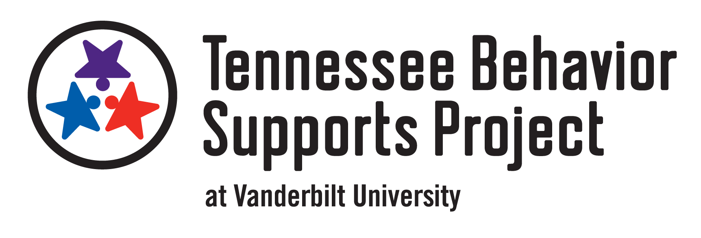
Tier II
Before Tier II Training
- Contact team and introduce yourself
- Attend your team’s Pre-Implementation Tier II TFI with TBSP Educational Consultant
During Tier II Training
- Attend training and support your teams during activity times
- Prompt teams to review their baseline TFI data and identify areas to strengthen
- Prompt teams to add to their Tier II Training Action Planning Form after each activity
- Help schools align district initiatives
- Provide feedback to teams on their plan
After Tier II Training/Throughout Planning
- Follow-up with team about Tier II & CICO Implementation Manual and action plan for the upcoming year
- Prompt teams to prepare implementation materials (refer to Tier II Implementation Checklist)
- Prompt teams to organize and facilitate faculty and staff roll-out and training
- Help teams develop a plan for training identified students and their families
- Help teams organize their data for identifying students (e.g., universal behavior screener, ODRs, attendance, teacher nomination)
- Provide team feedback on their Tier II & CICO Implementation Manual
- Remind team to send TBSP their Tier II & CICO Implementation Manual
Ongoing Throughout School Year
- Attend regular Tier II Team meetings
- Access resources from TBSP
- Help schools as needed with implementation and use of data
- Provide resources, feedback, and prompting
- Attend Team Lead Meetings provided by TBSP
- Maintain regular communication with TBSP Educational Consultant
August
- Support teams during faculty and staff roll-out and training of Tier II and CICO
- Help team establish their system to use data to identify students
- Encourage teams as they pilot CICO with a small group of students and begin implementing other Tier II interventions, if applicable
- Remind teams to collect baseline DPR data before a student begins CICO
- Attend Tier II meeting(s)
- Help teams use the Progress Monitoring Tool to track student DPR data
September
- Prompt schools to complete universal behavior screener
- Help teams use data to identify students
- Help teams use the Progress Monitoring Tool to track student DPR data
- Encourage team discussions about progress monitoring data (e.g., students who are responding positively to CICO and should begin self-management and fading as well as students who are responding poorly and need an adaptation to CICO)
- Collect fidelity of implementation data using fidelity checklists and DPR reviews for each student
- Help teams continue to pilot CICO
October
- Discuss pilot CICO and any changes that need to be made
- Work with team to plan for full CICO implementation
- Prompt teams to remind staff of how to provide feedback and complete DPRs
- Conduct Fall TFI with school teams and provide feedback about action planning and implementation
  - Note, the TFI can only be completed electronically once per window on pbisapps.org, so consider completing the first tier with the team on a paper copy and putting that data into pbisapps.org as you complete the second tier electronically with your team.
- Help team review Tier II data (e.g., entrance criteria, progress monitoring, exit criteria, and fidelity of implementation data)
November
- Help team review Tier II TFI data and use TFI Action Planning Form
- Support team as they continue full CICO implementation
- Help team review Tier II data (e.g., entrance criteria, progress monitoring, exit criteria, and fidelity of implementation data)
December
- Prompt schools to complete winter universal behavior screener
- Support team as they continue full CICO implementation
- Help team review Tier II data (e.g., entrance criteria, progress monitoring, exit criteria, and fidelity of implementation data)
January
- Prompt teams to remind staff of the Tier II plan and their role in CICO
- Support team as they continue full CICO implementation
- Help team review Tier II data (e.g., entrance criteria, progress monitoring, exit criteria, and fidelity of implementation data)
February
- Encourage faculty and staff to complete the PIRS Survey
- Support team as they continue full CICO implementation
- Help team review Tier II data (e.g., entrance criteria, progress monitoring, exit criteria, and fidelity of implementation data)
March
- Prompt teams to remind staff of the Tier II plan and their role in CICO after spring break
- Support team as they continue full CICO implementation
- Help team review Tier II data (e.g., entrance criteria, progress monitoring, exit criteria, and fidelity of implementation data)
April
- Prompt schools to complete spring universal behavior screener
- Support team as they continue full CICO implementation
- Help team review Tier II data (e.g., entrance criteria, progress monitoring, exit criteria, and fidelity of implementation data)
May/End of Year
- Conduct Spring TFI with school teams and provide feedback about action planning and implementation
  - Note, the TFI can only be completed electronically once per window on pbisapps.org, so consider completing the first tier with the team on a paper copy and putting that data into pbisapps.org as you complete the second tier electronically with your team.
- Help team review Tier II data (e.g., entrance criteria, progress monitoring, exit criteria, and fidelity of implementation data)
- Prompt Team Leads and Administrators to complete the Annual Report
Summer
- Help teams make changes to their Tier II plan (consider staff input)
- Help schools align new initiatives with RTI²-B, if applicable
- Meet with teams to plan for the upcoming year
Accessing Additional Tier II Resources
- Visit www.tennesseebsp.org
- Click on Tiers, then click on Tier II
- Click on Team Log-In, then click on Tier II, then enter password tbsp2 to access training materials

