How I Take A Break  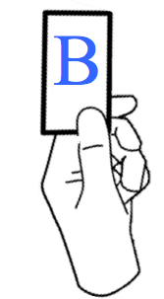  - Hold up my B  - Wait for a thumbs-up or thumbs-down  - If I get a thumbs-up, give my B to my teacher  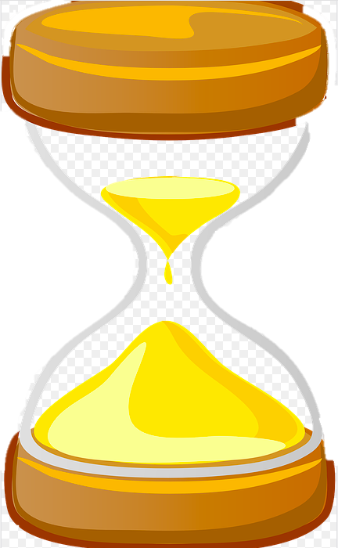  - Start my timer  - Take my break quietly  - Go back to work when the timer goes off | My Break Options Are:
What if my teacher gives me a thumbs-down?
- Put my B on my desk

- Start my timer but keep working

- When the timer goes off, I can hold up my B to ask for a break again
Break Routine Card Examples
How I Take A Break  - Hold up my pointer finger  - Wait for a thumbs-up or thumbs-down  - If I get a thumbs-up, cross off a “B” on my point card  - Start my timer  - Take my break quietly  - Go back to work when the timer goes off | My Break Options Are:
What if my teacher gives me a thumbs-down?
- Put my hand down

- Start my timer but keep working

- When the timer goes off, I can hold up my pointer finger to ask for a break again

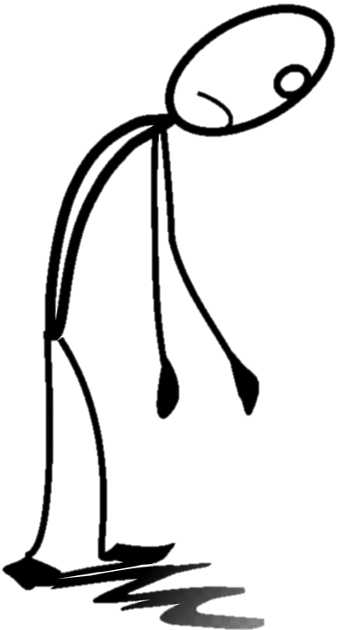
How to Take a Break
Ask yourself:
Is now a good time for a break?
Hold up my B card
Wait quietly until it is a good time
Did the teacher give me a thumbs-up?
Start my timer and take my break quietly
THAT’S OK!
Put my B back on my desk
Go back to work when my timer goes off
Start my timer but keep working
When the timer goes off, I can hold up my B to ask for a break again!
YES!
Not Really
YES!
Not this time
2 Minutes
2 Minutes
MY BREAK OPTIONS ARE:
I could really use a break!
How to Take a Break
Ask yourself:
Is now a good time for a break?
Hold up my pointer finger
Wait quietly until it is a good time
Did the teacher give me a thumbs-up?
Cross off a B on my point card. Start my timer. Take my break quietly.
THAT’S OK!
Put my hand down
Go back to work when my timer goes off
Start my timer but keep working
When the timer goes off, I can hold up my B to ask for a break again!
YES!
Not Really
YES!
Not this time
2 Minutes
2 Minutes
MY BREAK OPTIONS ARE:

I could really use a break!

