INSERT SCHOOL NAME

Tier I

Implementation Manual

2021-2022

Implementation Plan designed by the Tier I School Team Members:
INSERT TEAM MEMBER NAMES HERE

Table of Contents
Tennessee Multi-Tiered System of Supports Center Statement 3
Multi-Tiered System of Supports (MTSS) Overview 3
Tier I Documents 6
Dream Climate 6
Purpose Statement 6
Tier I Team Roles & Responsibilities 7
Tier I Team Meeting Foundations Form 8
Tier I Team Meeting Agenda 9
Behavioral Expectations and Behavioral Expectations Matrix 11
Lesson Plans 13
Teaching the Plan 14
Planning for Stakeholder Input 18
Acknowledgement System Matrix 19
Problem Behavior Definitions and Office-Managed vs. Staff-Managed Chart 21
Discipline Process Flowchart 23
Office Discipline Referral (ODR) Form 24
Data Collection Plan 25
Useful Tier I Resources 26
Strategies to Discourage Problem Behavior 26
Activities for Gathering Staff Input 28
Training Your Staff for Implementation 30
Tier I Implementation Checklist 31

Tennessee Multi-Tiered System of Supports Center Statement
Tennessee’s Multi-tiered System of Supports (MTSS) encompasses programs, practices, and interventions to support all students across learning domains — academic, behavioral, and social and emotional. The TN-MTSS Center provides training and support to improve district and school capacity to implement an integrated model of a multi-tiered system of supports. Our work centers around strengthening the essential components of this framework: screening, progress monitoring, a multi-level prevention and intervention system, and data-based decision making. The resources found in this document are designed to help your team establish a safe and welcoming school environment that optimizes learning opportunities and prioritizes high-quality instruction. For even more information on enhancing academic supports, visit the Tennessee Department of Education’s Response to Intervention Framework Manual.

Multi-Tiered System of Supports (MTSS) Overview
Establishing a Multi-Tiered System of Supports (MTSS) offers a powerful, evidence-based approach for meeting the academic, and non- academic (i.e., social, emotional, behavioral, etc.) needs of students in Tennessee schools. The Tennessee Department of Education’s Overview of Student Supports (2018) describes the MTSS framework:

Schools and districts have experience implementing student-focused, multi-tiered systems of support for academic needs through RTI². While RTI² focuses on academic instruction and intervention, students also require explicit instruction and aligned supports in non-academic areas, including behavior, social, and personal skills, to achieve success in academics. The MTSS framework encompasses RTI² in addition to Response to Instruction and Intervention for Behavior (RTI²-B) and other models of support. Working in concert, these programs complement each other and can better address the needs of the whole student. Neither academic nor non-academic concerns should be considered in isolation as the two often interact to contribute to a student’s strengths and needs. As a state, we are committed to developing well-rounded students who are prepared to successfully embark on their chosen path in life.

Tennessee’s MTSS model is comprised of four essential components: 1) screening, 2) progress monitoring, 3) a multi-level prevention and intervention system, and 4) data-based decision-making (as shown in Figure 2). Together, these components promote a responsive approach to student-focused learning in which instruction and intervention vary with student need.

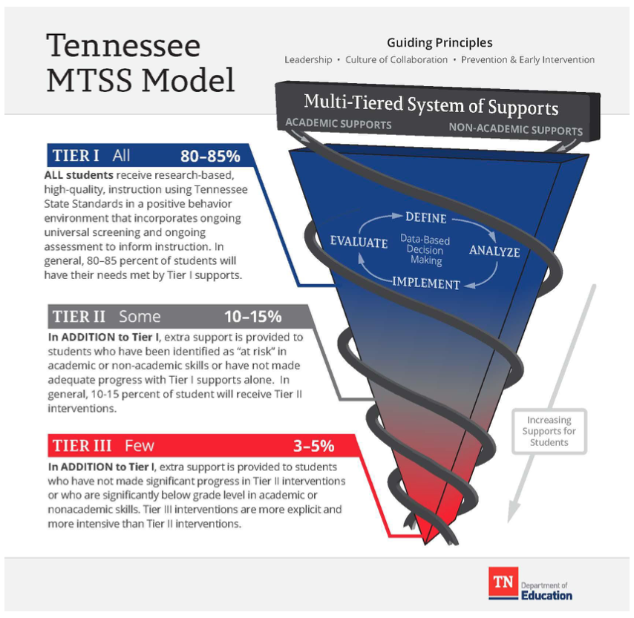

Figure 1
Tennessee’s MTSS Model

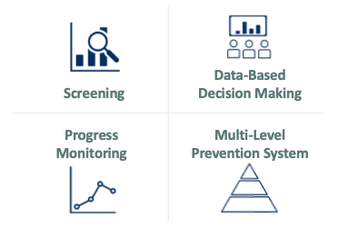
Figure 2
The Essential Components of Tennessee’s MTSS Framework

To maximize the efficiency and effectiveness of this responsive approach, Tennessee’s MTSS framework organizes instructional practices and interventions across three tiers of support. The implementation of non-academic supports within this three-tiered model is described below. Figure 3 depicts the percentage of students for whom each tier of support is designed.

Tier I: Tier I focuses on the behavioral and social needs of all students across the school environment. Approximately 80% of students typically respond to this level of support. Tier I includes establishing school-wide expectations to support a sense of safety and inclusion among students and staff, teaching and modeling those expectations within different settings throughout the school, positively acknowledging students and staff who follow these expectations, having a formal system for responding to inappropriate behavior, and maintaining a school-wide system where all stakeholders’ opinions are valued.

Tier II: Tier II involves delivering more targeted interventions for approximately 10-15% of students who do not respond to Tier I supports. Tier II interventions are provided in addition to Tier I supports in place for all students in the school. Interventions at Tier II are typically systematic, evidence-based interventions that are delivered to groups of students at a time. For example, Tier II interventions typically include small-group social skills instruction, behavior contracts, self-monitoring plans, and check-in/check-out.

Tier III: Tier III includes individualized interventions for approximately 3-5% of students who do not respond to Tier I or Tier II interventions and supports. Tier III interventions involve the implementation of specialized, one-on-one systems for students. Examples of Tier III supports include individualized counseling and function-based interventions.

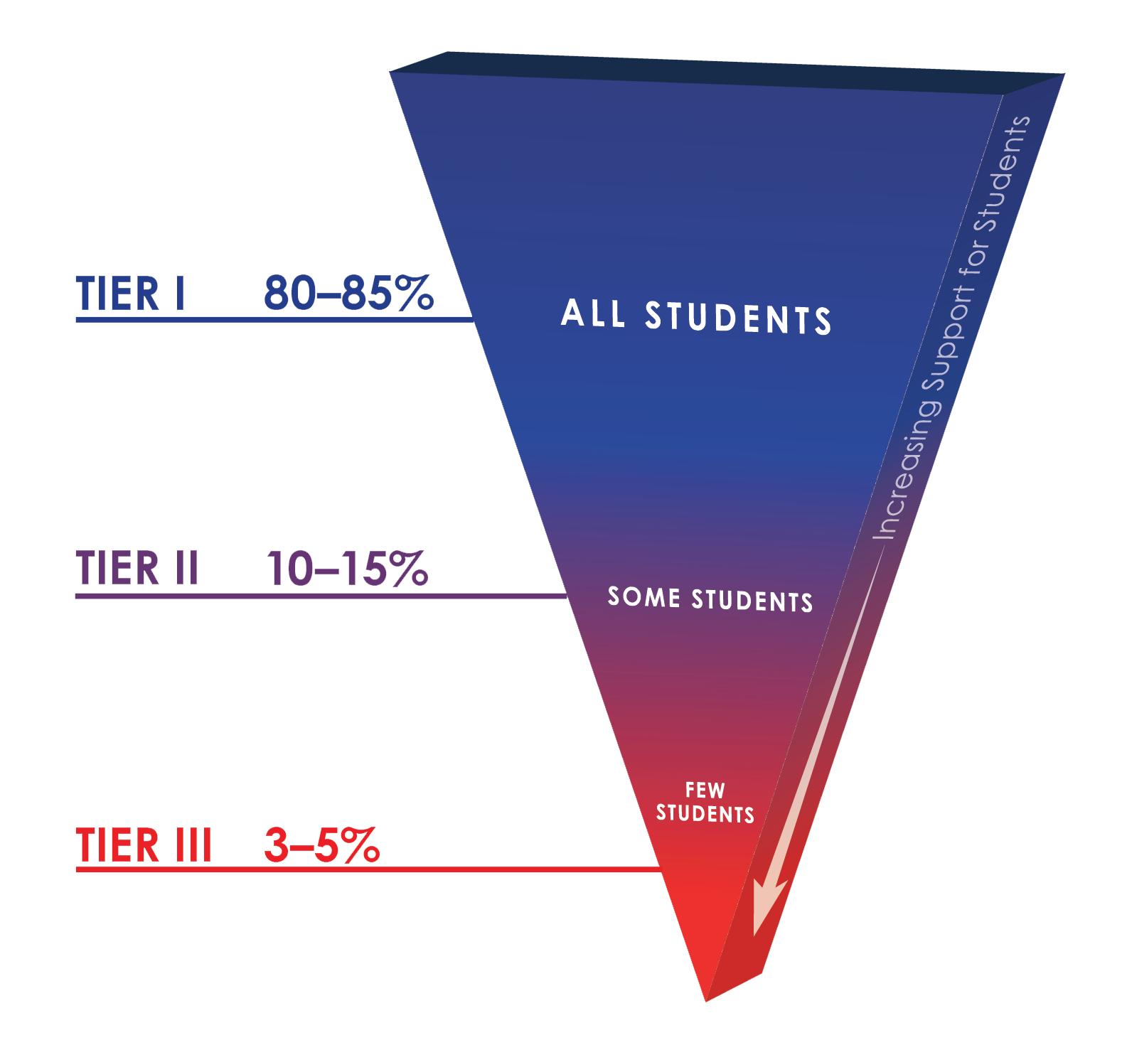
Figure 3
Intended Percentage of Students Across Tiers

Tier I Documents

Dream Climate
We discussed our vision for our dream school climate. This in an ongoing school-wide discussion, but referring back to our dream climate helps us shape our implementation goals.

Considerations
    - If you could create the school climate of your dreams, what would it look like and sound like to be in your building?
    - What are your intended outcomes for your school?
    - How will this align with your School Improvement Plan and your Mission?

Our Dream Climate
(Adapted from Mid-Atlantic PBIS Tier I Team Implementation Workbook)

Purpose Statement
We developed a brief statement purpose for our team to guide our work. We considered who we are serving, how we are adding value to our school, and exactly what we will be doing as we implement Tier I.
The purpose of our Tier I team is to:

Tier I School Team

Tier I Team Roles & Responsibilities
 | Before Meeting | During Meeting | After Meeting
Team Lead | - Schedules meetings  - Sets meeting agenda  - Sends meeting reminders | - Facilitates discussion  - Follows meetings norms and provides input | - Follows up on assigned tasks  - Completes assigned tasks
Recorder | - Creates meeting minutes  - Sends agenda before meeting | - Records meeting minutes  - Reviews action items with team  - Respectfully participates in meetings | - Shares minutes with team  - Completes assigned tasks
Data Analyst | - Prepares data and graphs  - Review Agenda | - Leads discussion on data  - Respectfully participates in meetings | - Completes assigned tasks
Communicator | - Collects input from staff to share at the meeting  - Review Agenda | - Represents staff voice  - Considers what training staff will need  - Respectfully participates in meetings | - Shares updates with all staff  - Completes assigned tasks
Time Keeper | - Reviews agenda | - Keeps team on topic  - Monitors time needed to discuss agenda  - Ensures meetings start and end on time  - Respectfully participates in meetings | - Completes assigned tasks

Tier I Team Meeting Foundations Form
Our Tier I Team reflected on the professional behaviors that characterize efficient and effective meetings during their training. The working agreements are listed below in an effort to support the team’s productivity.
Tier I Team Meeting Foundations Form
Team Norms | Decision Making Procedures

Team Roles & Responsibilities
 | Team Lead | Recorder | Data Analyst | Communicator | Time Keeper
Primary
Back Up
Responsibilities | Meeting Agenda | Meeting Notes | Data Reports | Shares updates to staff | Keeps team on track

Team Meeting Schedule
When | Where | Start/End Time | Agenda & Meeting Minute Location

Data Tool | Data Collection &  Data Entry Schedule  Who & When | Report Generation  What, Who & When
Tiered Fidelity Inventory (TFI)
Universal Behavior Screener (SRSS-IE)
Office Discipline Referrals (ODRs)
Staff Feedback (PIRS)
Annual Report

Tier I Team Meeting Agenda
Our Tier I Team selected an agenda to use at every team meeting. This will help us have efficient and effective meetings. *Note: If you plan to use a different agenda, then replace this example with the agenda your team uses for Tier I Meetings

Tier I Team Meeting Minutes Form
Meetings: | Date/Time: | Location: | Team Lead: | Recorder: | Data Analyst: | Communicator: | Time Keeper:
Today’s Meeting
Next Meeting

Tier I Team Members (Place “X” to left of name if present)

Today’s Agenda (Place “X” to left of item after completed) |  |  |  | Agenda Items for Next Meeting:
 | Review Agenda (2 min) |  | Data Review (10 min)
 | Celebrations (3 min) |  | Administrative/General Issues (15 mins)
 | Review Previous Meeting’s Tasks (5 min) |  | Assign Action Items (5 min)
 | Meeting Foundations/Upcoming Data  (2 min) |  | Evaluation of Team Meeting (1 min)

Administrative/General Information and Issues
Issue/Information | Discussion/Decision/Task | By When? | Who? | Staff Communication

Data Review
ODR Review for ODRs, SRSS-IE Spreadsheet, TFI Report at pbisassessment.org, PIRS Report, Annual Report
Data Tool | Discussion/Decision/Task | Goal | By When? | Who? | Staff Communication

Evaluation of Team Meeting (Mark your ratings with an “X”) | Our Rating
 | Yes | So-So | No
1. Was today’s meeting a good use of our time?
2. In general, did we do a good job of tracking whether we’re completing the tasks we agreed on at previous meetings?
3. In general, have we done a good job of actually completing the tasks we agreed on at previous meetings?
4. In general, are the completed tasks having the desired effects on student behavior?

Behavioral Expectations

Behavioral Expectations and Behavioral Expectations Matrix
Our school’s agreed upon behavioral expectations are operationally defined with examples of what the expected behavior looks like in each location. This will improve clarity and consistency of what is expected throughout the school.

Name of Behavioral Expectations: | Examples:  Eagle Expectations  Wilson Wisdoms
Expectations should be:  - Positively Stated  - Clear and Concise  - Memorable  - Applicable to all settings  - Applicable to all people | List Expectations:  (must have 3-5 expectations)  1.  2.  3.  4.  5.

Expectations Matrix Considerations:
- Determine your matrix layout (Locations at the top or Expectations at the top)
- Add your agreed upon behavioral expectations
- List your locations using the map of your school
- Fill in each cell of the matrix one location at a time
- Remember to operationally define the best example of the expected behavior

Expectations OR Locations
Locations OR Expectations

Teaching Expectations to Students, Staff, Family and Community

Lesson Plans
Lesson Plans are an important way to consistently teach all students the behavioral expectations in all locations throughout the school. Together as a team, we created lesson plans for every setting, and they are listed below.
*Note: If you plan to use a different lesson plan template, then replace this example with your lesson plans and be sure to add all Behavioral Expectations Lesson Plans to this manual (one for each setting).

Behavioral Expectations Lesson Plan
Lesson plans should be taught in the area and take 10-15 minutes

Objective:
Setting:

Expectations:

(see behavior expectation matrix)

Examples:

Teach using “I do, we do, you do”

Non-examples:

(Adults model only)

Follow Through and Practice:

(How will behavior expectations continue to be taught throughout the school year?)

Acknowledgement:

(How will behaviors be acknowledged in this setting?)

Lesson Plans
The Tier I School Team added the Tier I Calendar Components to our school calendar in an effort to organize our implementation efforts.
Tier I Calendar Components | Date(s)
Tier I Team Meetings
Initial Session to Teach Core Components to Staff
Booster Sessions to Teach Core Components to Staff
Begin School-wide Implementation
(e.g., Kick-off Celebration)
Teaching Expectation Lesson Plans to Students in All Settings
Re-teaching Expectation Lesson Plans to Students in All Settings
Celebrations/Assemblies
Family Nights
Other:

Teaching the Plan
Our Tier I Team worked through the logistics of teaching the plan to all students, staff, family and community in our school, and the details are listed in the charts below.

Teaching the Plan to Students
How will you introduce the plan to students?
(e.g., describe steps for first introducing the school-wide plan to all students)
Who will teach the expectations to the students?  What materials are needed to teach the expectations?  Where will instruction take place?  How will the acknowledgement system be explained? | When:
How will you create and post the expectations in all locations?
What will it look like?  Who will create it?  Who will post it?  Where will they be posted? | When:
How will you review the plan and reteach lessons throughout the year?
(e.g., after each break)
Who will review the lessons with students?  What materials are needed to teach the lessons?  Where will instruction take place? | When:
How will you teach the plan to new students throughout the year?
Who will teach the plan to new students?  What materials are needed to teach the plan?  Where will instruction take place? | When:
(Adapted from Mid-Atlantic PBIS Tier I Team Implementation Workbook)

Teaching the Plan to Staff
How will you train staff on the plan?
Who will be trained? (e.g. paraprofessionals, teachers, bus drivers, custodial staff, cafeteria workers, office workers)  Who will present the information?  What materials will you need to train?  Where will you train?  How long will training last? | When:
How will you train staff to teach expectations and deliver acknowledgements?
What materials will you need?  Who will present the information? | When:
How will you teach the components of the discipline process to all staff?
(e.g., behavior definitions, office-managed vs. staff-managed, discipline process flowchart)
What materials will you need?  Who will present the information? | When:
How will you teach core features of the plan to substitute teachers?
(e.g., expectations, acknowledgements, discipline)
What materials will you need?  Who will be responsible for providing materials/informing the substitutes? | When:

Teaching the Plan to Family and Community
How will core features of the plan be shared with family/community members at the beginning of the school year? (e.g. expectations, acknowledgements, discipline)
Who will present the plan/share information?  What materials will be shared? | When:
How can families incorporate this in the home?
(e.g., home matrix, home acknowledgement system)
How will these resources will be shared? | When:
What additional resources can family/community members access for more MTSS information and support? (e.g., online resources, resources within the district)
Where can they find these resources?  How will these resources be shared? | When:
Who will be the liaison between the school and family/community?
 | When:
How can family/community members get involved with MTSS at your school?
 | When:
Does your school have an established parent organization? If so, who will communicate with the parent organization?
 | When:

Planning for Stakeholder Input
Our Tier I team discussed possible ways to involve our school community (students, staff, family/community) in developing the MTSS framework at our school. We hope to receive their input and continued feedback.

 | Behavioral Expectations | Teaching and  Re-teaching of Expectations | Acknowledgement System | Discipline  Process
Staff
Students
Family/
Community
(Adapted from Mid-Atlantic PBIS Tier I Team Implementation Workbook)

Acknowledgment System

Acknowledgement System Matrix
Our team discussed possible ways to acknowledge students, staff, and family/community throughout the school year in an effort to acknowledge expected behaviors and show appreciation of their continued support.

Considerations:
      - Consider various ideas for acknowledging students/staff/families/community
      - Link system to your behavioral expectations
      - Use across settings
      - Share this acknowledgement system with all stakeholders
 | School-wide Acknowledgment System Matrix
 | Name and Type | Description | When (frequency) | Where (location) | Who (distributors)
Students |  | What:  How:
What:

How:

What:

How:

What:

How:

 | Name and Type | Description | When (frequency) | Where (location) | Who (distributors)
Staff |  | What:  How:
What:

How:

What:

How:

What:

How:

 | Name and Type | Description | When (frequency) | Where (location) | Who (distributors)
Family/Community |  | What:  How:
What:

How:

What:

How:

(Adapted from Mid-Atlantic PBIS Tier I Team Implementation Workbook)

Problem Behavior Definitions and Discipline Procedures

Problem Behavior Definitions and Office-Managed vs. Staff-Managed Chart
Our school categorizes problem behaviors as office-managed and staff-managed. We used our school’s discipline handbook and the behavior definitions to determine which problem behaviors will be office-managed and which will be staff-managed in our discipline process. We also agreed on the definitions, examples, and non-examples listed below.
Staff-Managed Problem Behavior | Violation | Definition | Examples | Non-Examples
**If a student has an IEP or FBA/BIP adhere to those plans first.

Office-Managed Problem Behavior | Violation | Definition | Examples | Non-Examples
**If a student has an IEP or FBA/BIP adhere to those plans first.

Discipline Process Flowchart
Together as a team, we updated our Discipline Process Flowchart and it is provided below. This will help improve consistency on the steps to take when problem behaviors occur. *Note: If you plan to use a different flowchart template, then replace this example flowchart with the one your school will be using.
Observe Problem Behavior

Is Behavior
Office-Managed?

Office Managed
Teacher Managed

NO YES
Administrator provides feedback to teacher in a timely manner.
Administrator follows through on consequence.
Complete office discipline referral (ODR).
Use Teacher Consequence(s):

Send student to Office, or call Office to have student removed.

If behavior is unchanged, and all consequences have been given, contact the parent to discuss the behavior.

Has teacher contacted parent 3 times regarding the behavior?

No Yes
Write referral to the office, using an ODR form.
Continue teacher management until 3 parent contacts have been made.

Office Discipline Referral (ODR) Form
ODR Forms are an important way to collect data on problem behaviors occurring in our school. Together as a team, we checked to see if the essential elements are included in our school’s ODR form, and our updated form is located below. *Note: If you plan to use a different ODR form template, then replace this example form with the one your school will be using.
Office Discipline Referral Form
Name: ________________________________________________  Date: _________________________ Time: __________________  Teacher: ______________________________________________  Grade: K 1 2 3 4 5 6 7 8 9 10 11 12  Referring Staff: _________________________________________  Others Involved in Incident:  ☐None ☐Peers ☐Staff ☐Teacher ☐Substitute ☐Unknown  ☐Other: _______ |  | Location  - Playground  - Cafeteria  - Hallway  - Classroom  - Library  - Bathroom  - Arrival/Dismissal  - Other: ________
Activity the student was engaged in when the event took place:
☐Whole group instruction ☐Small group instruction ☐Individual Work ☐Alone
☐Working with peers ☐One-on-one instruction ☐Interacting with peers ☐Other_________
Staff-Managed Problem Behavior | Office-Managed Problem Behavior | Possible Motivation
- Inappropriate Language  - Physical Contact  - Defiance  - Disruption  - Dress Code  - Property Misuse  - Tardy  - Electronic Violation  - Other: ________________ | - Abusive Language  - Fighting/Physical Aggression  - Defiance/Disrespect  - Harassment/Bullying  - Dress Code  - Inappropriate Display Aff.  - Electronic Violation  - Lying/Cheating  - Skipping Class  - Other: ________________ | - Obtain peer attention  - Obtain adult attention  - Obtain items/activities  - Avoid Peer(s)  - Avoid Adult  - Avoid task or activity  - Don’t know  - Nurse  - School Counselor  - Other: ________________
Administrative Decision |  | Other Comments
- Loss of privilege  - Time in office  - Conference with student  - Parent Contact  - Individualized instruction | - In-school suspension  ( _____ hours/days)  - Out of school suspension  ( _____ hours/days)  - Other: ________________
Parent Signature: _____________________________________________ Date: _____________________

Data-Based Decision Making

Data Collection Plan
This chart is a document the team used to organize Tier I school data. Data will be collected in various ways throughout the year, and the team will look at this data to make decisions. Your school may add additional school-wide data to this chart (e.g., course performance data, attendance data, counseling or nurse referrals, or classroom-managed problem behavior data) for the team to review.
Data | Evaluation Tool | Collection Schedule
Office Discipline Referrals (ODR) Data | Our school uses:  (e.g., SWIS, PowerSchool,  Infinite Campus, Skyward) | Recommendation: Summarize discipline data monthly  Suggested plan: We will look at ODR at our monthly meetings.
Universal Behavior Screener | Student Risk Screening Scale for Internalizing and Externalizing Behavior (SRSS-IE) | Recommendation: Three times per year (fall, winter, and spring)  Suggested plan: Teachers will complete the screener in September, December, and April.
Fidelity Data | Tiered Fidelity Inventory (TFI) | Recommendation: Two times per year (fall and spring)  Suggested plan: The Tier I team will complete the TFI with an MTSS District Coach at our meetings in October and May.
Social Validity | Primary Intervention Rating Scale (PIRS) | Recommendation: Once per year in the spring  Suggested plan: All staff will complete the electronic survey emailed to them in February.
Annual Evaluation | Annual School Report | Required: Annually at the end of the school year for implementing schools  Suggested plan: The Tier I Team will complete the Annual Report at the end of the year and submit by June 15th.

Useful Tier I Resources

Strategies to Discourage Problem Behavior
The chart below gives examples of helpful classroom strategies. Discuss which are best for the scenarios discussed at training as well as scenarios from your building.
Strategy | Explanation | Example
Re-direct | This strategy employs a very brief, clearly and privately stated verbal reminder of the expected behavior. A re-direct includes a specific statement of the school-wide, non-classroom or classroom rule/procedure. A re-direct emphasizes the “what” of the behavior instead of the “why.” | “Jason, please begin your writing assignment.” (Later) “Nice job being responsible, Jason, you have begun your assignment.”
Re-teach | Re-teaching builds on the re-direct above and re-teaches the specific expectation in question and reminds of the procedures or routine for doing so. It capitalizes on the teachable moment to review the expectation more thoroughly yet briefly. As in all instruction, you label the skill, teach and show, and give the students the immediate opportunity to practice demonstrating the behavior. Once the student uses the appropriate behavior, then specific positive feedback should follow. | “Jason, you need to be responsible by being on-task. That means your desk is clear of everything except your book and notebook, you begin working right away, continue working until done, and if you need help, you raise your hand. (Pause) Nice job being responsible, Jason; it looks like you are ready to work. Let me know if you need help.”
Provide Choice | Providing choice can be used when re-directs or re-teaching have not worked. This is the statement of two alternatives: the preferred or desired behavior and a less-preferred choice. When options are paired this way, students will often make the preferred choice. Pause after providing the choice, and when the student chooses wisely, praise. | “McKenzie, you are asked to get on-task and begin your work or you can finish the activity later today during our special activity. I will watch to see if you would rather begin now.”  OR  “Lynn, you can get organized and work here at your seat, or you can work in the quiet area. Which would you prefer?”
Student Conference | This is a lengthier re-teaching or problem-solving opportunity when behavior is more frequent or intense. The behavior of concern is discussed, the desired behavior is taught, and a plan is made to ensure the behavior is used in the future. This is to be done when students are calm, not while students are escalated. | “B.J., several times today I have reminded you about being on-task. When you are given an assignment, you need to . . . When you do that, you can finish faster and move on to things you enjoy. Tell me what you will do when given an assignment. Let’s practice . . . How can I help you do that if you get stuck?” (then) “Can I get a commitment from you to do that?”
Proximity | Every teacher knows how effective it is to stand near a child who is having difficulty. This technique is the strategic placement/movement by the teacher in order to encourage positive behavior. The teacher is a source of support and strength and helps the student to control his impulses by her proximity. | When Alan is off-task or talking, the teacher continues to teach the group while, at the same time, moving toward Alan or even standing next to him for a moment. Once Alan brings his behavior in line, brief specific positive feedback will help maintain the desired behavior. “Thanks, Alan, for showing respect with your attention.”
Signal Non-verbal Cue | Teachers have a variety of signals that communicate to the student(s) what is expected. These non-verbal techniques include such things as eye contact, hand gestures, picture cues, etc. Such simple cues suggest that the teacher is aware of the student’s behavior and is prepared to intervene if the behavior continues. This works best when the teacher has a relationship with the student(s) and the non-verbal cues have already been taught to the group. | When Sarah begins to talk to her neighbor, the teacher glances in her direction and holds the look until she is again quiet and attending. The teacher then praises Sarah for her attention.  The group of students is getting restless. The teacher uses her hand to signal to regain their attention, then praises the group and reminds them of the expectations for independent work time.
Ignore/  Attend/Praise | This technique is based on the power of praise or specific positive feedback. The teacher praises an appropriately behaving student in proximity to the inappropriately behaving student. The praise serves as an indirect prompt for the misbehaving student and reinforcement for the one behaving appropriately. When the student exhibits the appropriate behavior, then attention and praise are provided. | James is off-task during independent work time. The teacher briefly ignores James and specifically praises a student nearby who is on-task, “LeBron, thank you for working on the correct assignment!” When James begins to get back on-task, then the teacher immediately praises him, “Thanks, James for being on-task. You’ll be sure to get your work done.”

Activities for Gathering Staff Input
The chart below lists suggestions on how to gather staff input on components of your Tier I plan. Select one or two activity ideas from each category (Foundations, Behavioral Expectations, and Problem Behavior Definitions) to complete with your staff. These can be done at faculty meetings, grade level-meetings, department meetings, or PLCs.

Suggested Activities |  | References
Foundations | - Complete “Dream Climate Activity” with staff | Implementation Manual
 | - Show foundational videos: | “Atlanta Speech School” https://www.youtube.com/watch?v=VxyxywShewI  “Overview Video”  http://tennesseebsp.org/videos/
 | - Share your team’s purpose statement | Implementation Manual
 | - Review the TFI Report:  - discuss strengths and areas for growth  - discuss using TFI as a foundation for building the plan | Refer to “TFI Tier I Score Report”
 | - Distribute staff survey | Example Binder Section 7. Faculty Involvement

Behavioral Expectations | - All staff place a sticker on a school map indicating where they think the most problem behaviors occur  - As a staff determine expectations for those locations and develop the matrix for those areas | Implementation Manual
 | - Everyone reviews the draft of the behavioral expectations matrix and provides suggestions on what to change or add | Implementation Manual
 | - Review expectations vs. rules when explaining the expectations matrix and ask for feedback | Day 1 Presentation  Implementation Manual
 | - Send lesson plans to each grade level/department chair to review with team to provide feedback or develop additional lesson plan ideas | Implementation Manual

Suggested Activities |  | References
Problem Behavior Definitions | - With staff sort problem behaviors into Office-Managed vs. Staff Managed | Implementation Manual
 | - Discuss problem behaviors sorted as both Office-Managed vs. Staff-Managed (Major vs. Minor) and clarify definitions for those behaviors | Implementation Manual
 | - Provide staff with the top three problem behaviors using ODR data  - have staff come up with a definition of those problem behaviors  - come to a group consensus on what the school-wide definition, examples, and non-examples will be for those problem behaviors | School Office Discipline Referral Data (ODR)
 | - Show staff the Cost/Benefit Worksheet and how time could be regained for students, teachers, and administrators | Day 1 Presentation  http://www.pbismaryland.org/

Training Your Staff for Implementation
Use this chart to organize the aspects of your Tier I plan that will need to be shared with staff.
Behavioral Expectations and  Teaching Expectations  - Provide expectations to faculty and staff and provide rationale for why expectations will be similar throughout the school.  - Explain the difference between a School-wide Expectation and the behaviors listed in the expectation Matrix.  - Ask faculty and staff to review the expectations and see if there are any missing.  - Have each table review the matrix and present to other faculty what the expectations look like in each school setting. | Problem Behavior Definitions and  Discipline Procedures  - Review Problem Behavior Definitions.  - To obtain staff buy-in allow faculty and staff to review definitions and sort (whole or small group) into office vs. staff managed  - Review Discipline Flowchart  - Use Discouraging Inappropriate Behavior Activity to review responses to problem behavior  - Review Office Discipline Referral  - Create scenarios and have staff practice writing referrals for each scenario.  - Review Minor Tracking Procedures  - Create scenarios for staff to determine whether each behavior is office or staff managed.
Feedback and Acknowledgement  - Review Feedback procedures with staff  - Discuss the use of acknowledgement at an adult level  - Use faculty acknowledgement system during presentation.  - Have grade levels or small groups brainstorm acceptable incentives for students (non-tangible or tangible).  - Have faculty and staff brainstorm school-wide incentives. | Faculty Involvement  - Review expectations for faculty involvement.  - Provide all materials to faculty at training  - Implementation Manual  - Tickets (if applicable)  - Problem Behavior definitions  - School-wide Expectation Posters  - Implementation Calendar  - Allow faculty to provide feedback on Tier I plan  - Surveys, anonymous comments, grade level chairs

Tier I Implementation Checklist
Use this checklist to determine what your team needs to complete prior to implementing Tier I.
Tier I Implementation Checklist
- Finalize Tier I Implementation Manual
- Tier I Team Meeting Foundations Form
- Tier I Team Meeting Agenda
- Behavioral Expectations Matrix
- Lesson Plans
- Calendar for Implementation (e.g., staff training, student roll-out, team meetings)
- Teaching the Plan to Students, Staff, and Family/Community
- Planning for Stakeholder Input
- Acknowledgement System Matrix
- Problem Behavior Definitions for Office-Managed vs. Staff-Managed Chart
- Discipline Process Flowchart
- Office Discipline Referral Form
- Data Collection Plan
- Finalize Materials to Share with Students, Staff, and Family/Community
- Behavioral expectations posters for all classrooms and all settings
- Tickets or other acknowledgement systems
- Ticket/Acknowledgement System Tip Sheet
- Reinforcer ideas list
- Staff presentation and roll-out plan (including Food Service, Custodial Staff, Transportation, and others as applicable)
- Implementation manual for all staff members
- Student kick off assembly and roll-out plan
- System to teach students the behavioral expectations lesson plans in all settings
- Presentation for families
- Letter to families
- Meet as a team to finalize all materials and set-up plan for student and staff roll-out
- Gather staff input on Tier I plan (ongoing)
- Send all finalized materials to your District Coordinator, your county’s TN-MTSS Center educational consultant, OR upload documents to tennessebsp.org

Notes on updating your Implementation Manual
- The Table of Contents automatically adjusts and reformats according to any changes you make. Use the following steps as a guideline to update page numbers:
  - Click on the title “Table of Contents”
  - A box should appear above where you clicked that says “Table” with an arrow
  - Click on the arrow that appears in the box
  - Click on “Update Table”
  - Click on “Update Page Numbers Only
  - Click “OK” and the page numbers should update
- Insert the listed items where called for, as indicated by yellow highlights. Delete the highlighted instructions when finished adding the materials. All requested items should be copy and pasted directly from activities that were completed during training.

