How I Take A Break  - Hold up my B  - Wait for a thumbs-up or thumbs-down  - If I get a thumbs-up, give my B to my teacher  - Start my timer  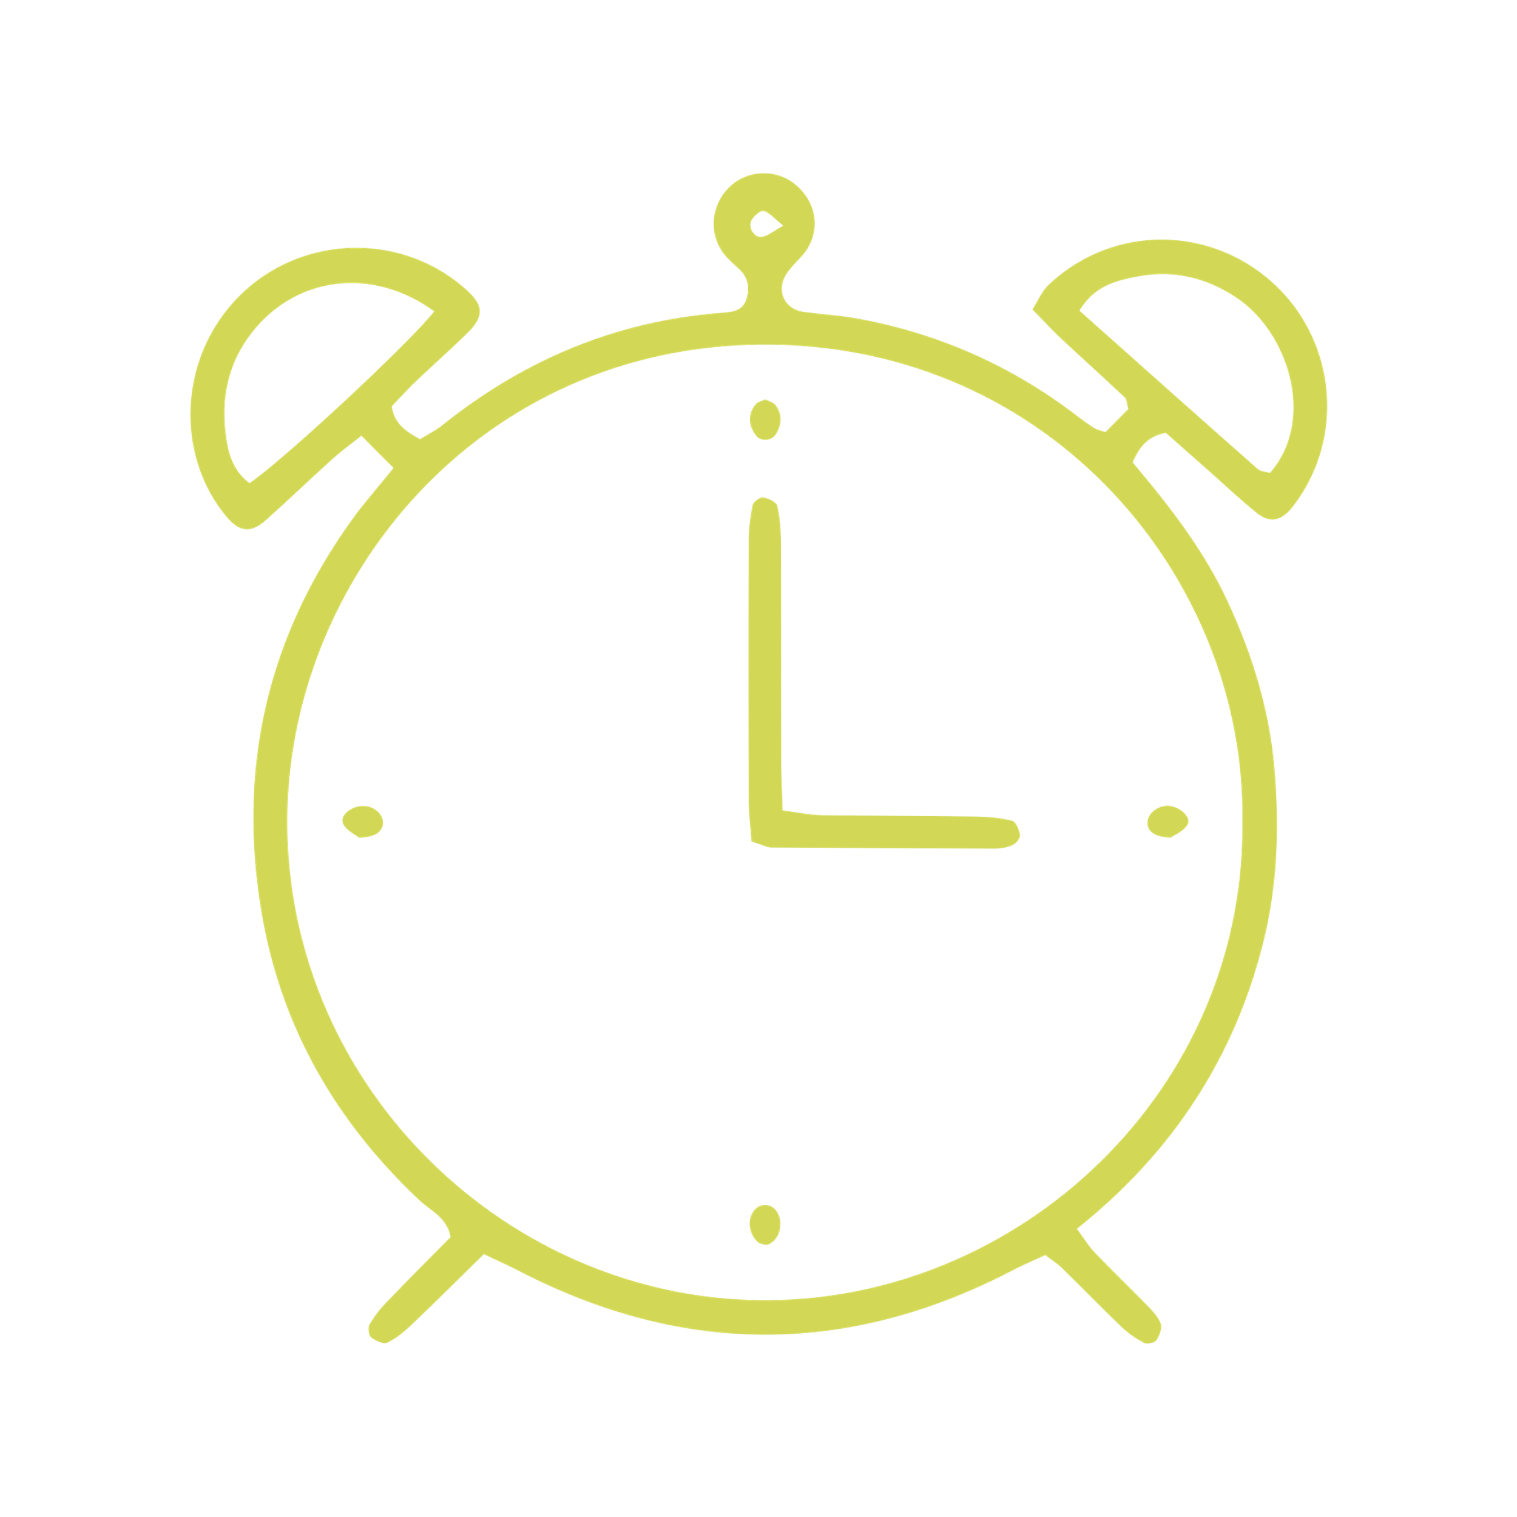  - Take my break quietly  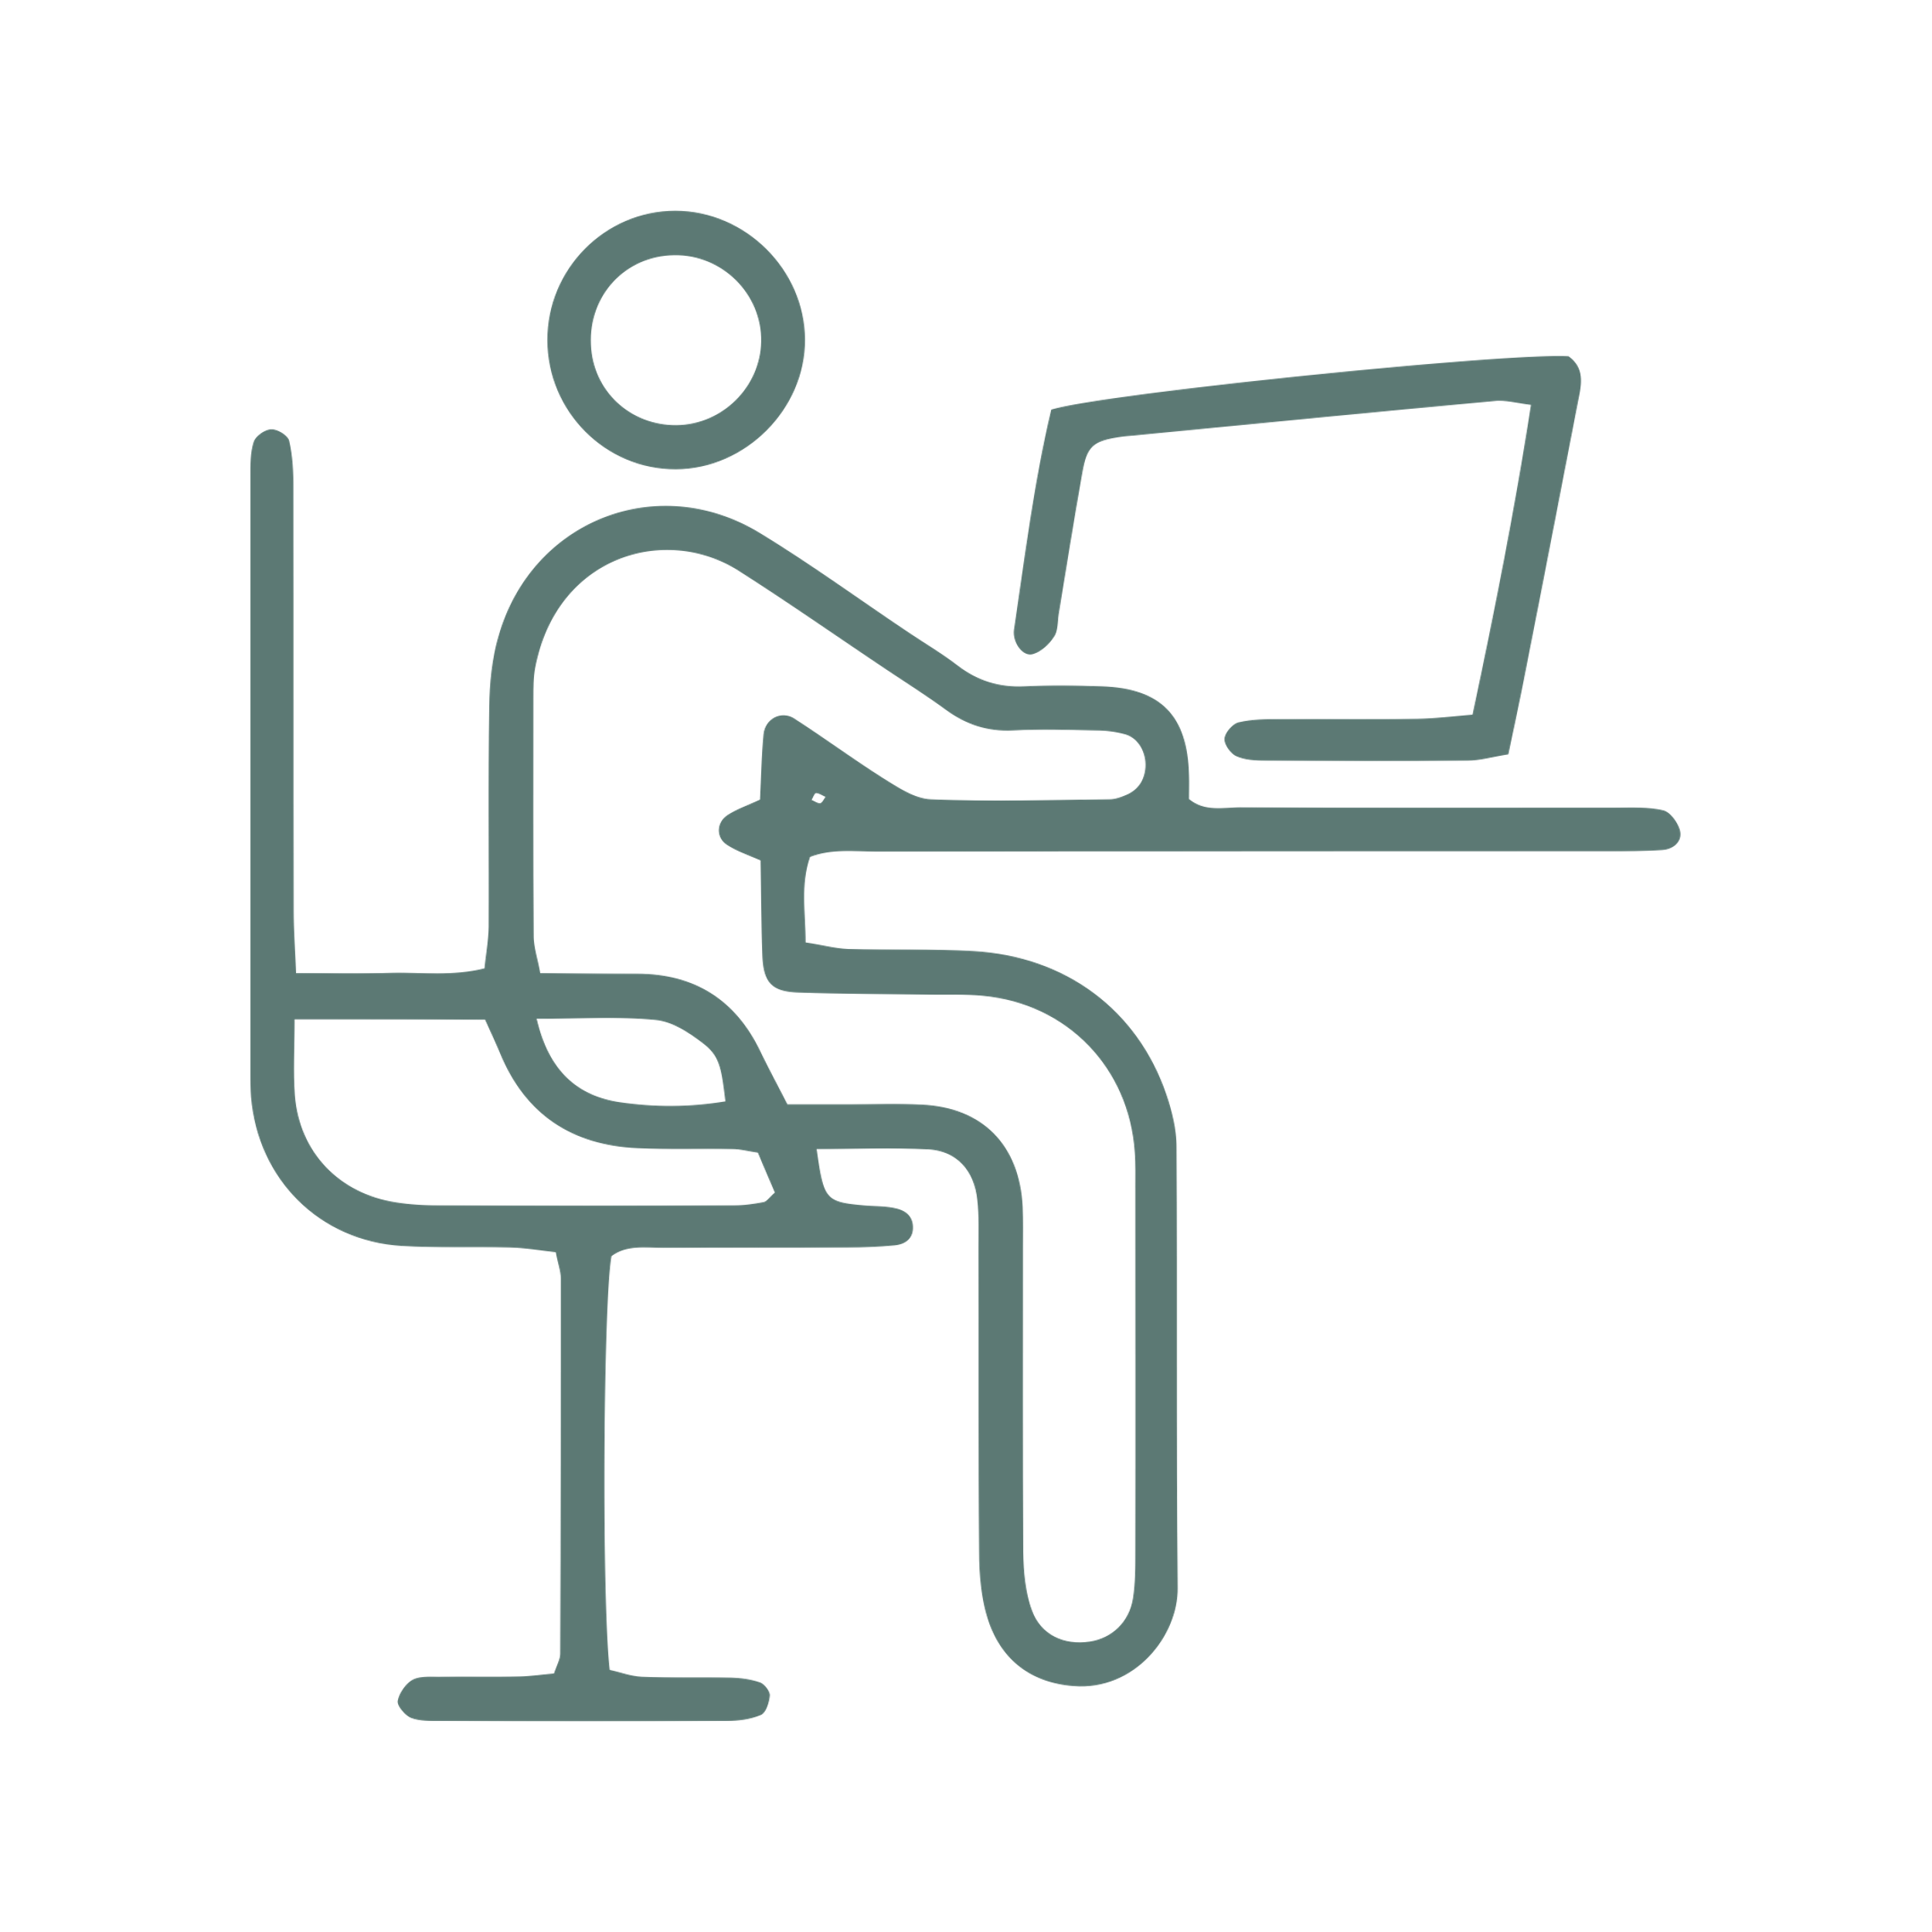  - Go back to work when the timer goes off | My Break Options Are:
What if my teacher gives me a thumbs-down?
- Put my B on my desk

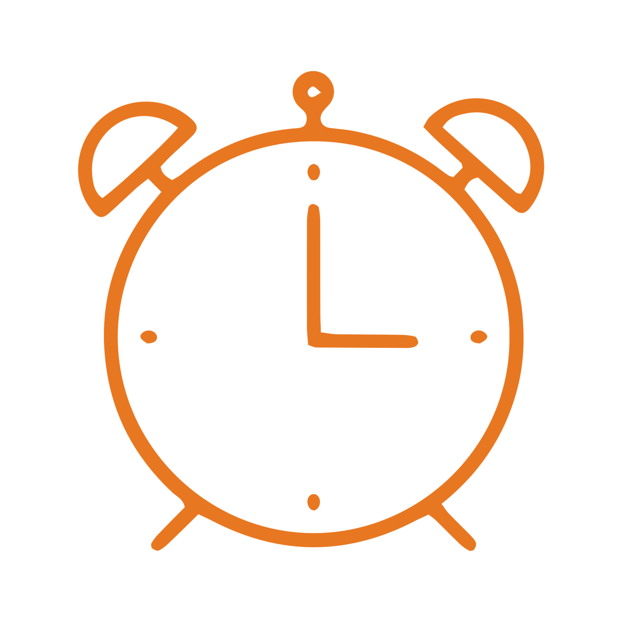
- Start my timer but keep working
- When the timer goes off, I can hold up my B to ask for a break again
Break Routine Card Examples
How I Take A Break  - Hold up my pointer finger  - Wait for a thumbs-up or thumbs-down  - If I get a thumbs-up, cross off a “B” on my point card  - Start my timer  - Take my break quietly  - Go back to work when the timer goes off | My Break Options Are:
What if my teacher gives me a thumbs-down?
- Put my hand down

- Start my timer but keep working
- When the timer goes off, I can hold up my pointer finger to ask for a break again
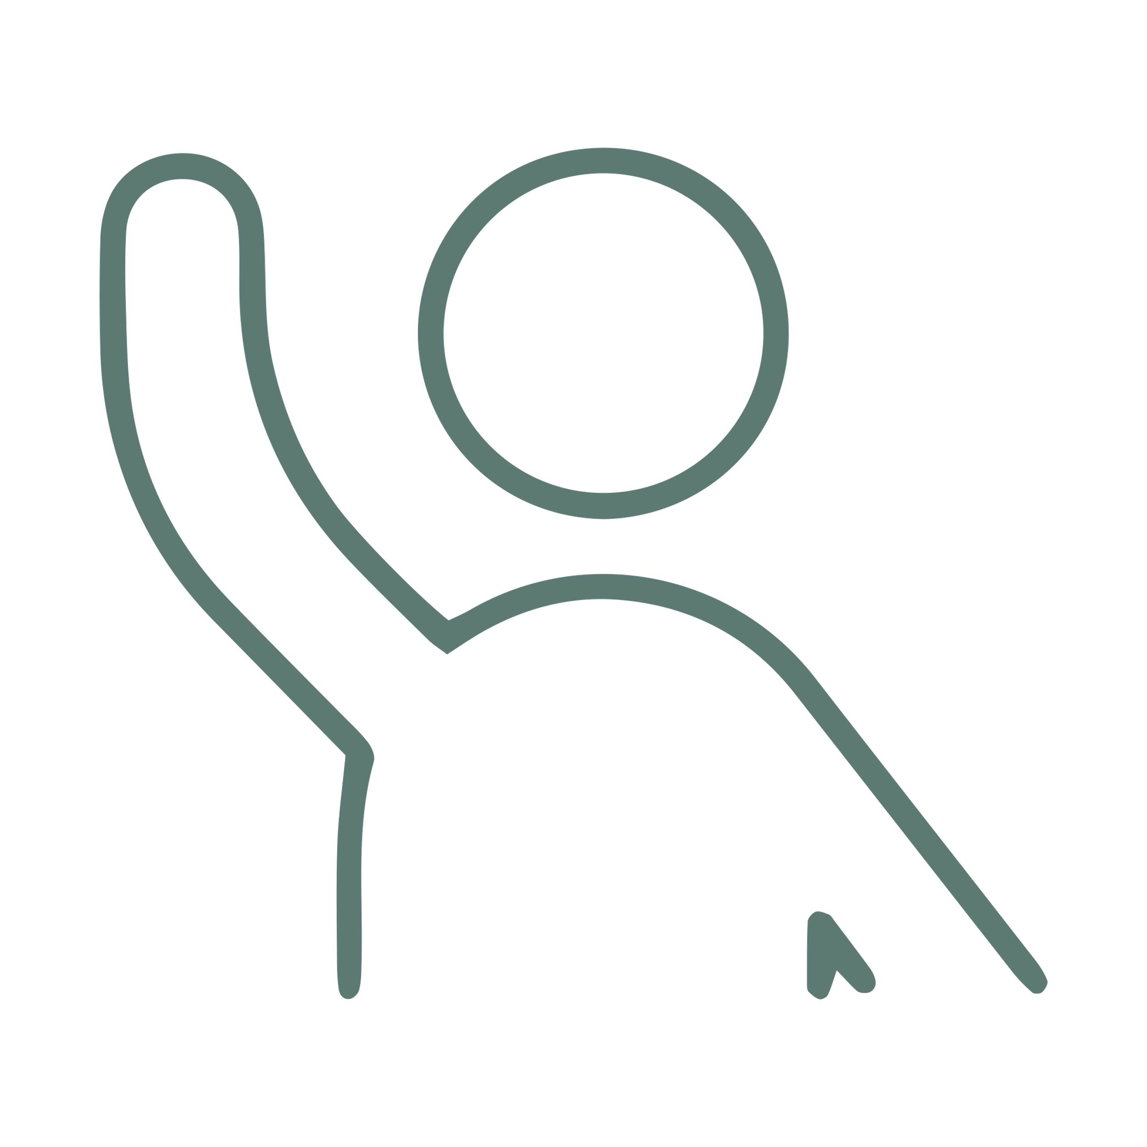
Ask yourself:
Is now a good time for a break?
Hold up my B card
Wait quietly until it is a good time
Did the teacher give me a thumbs-up?
Start my timer and take my break quietly
THAT’S OK!
Put my B back on my desk
Go back to work when my timer goes off
Start my timer but keep working
When the timer goes off, I can hold up my B to ask for a break again!
YES!
Not Really
YES!
Not this time
MY BREAK OPTIONS ARE:
I could really use a break!
How to Take a Break
Ask yourself:
Is now a good time for a break?
Hold up my pointer finger
Wait quietly until it is a good time
Did the teacher give me a thumbs-up?
Start my timer and take my break quietly
THAT’S OK!
Put my B back on my desk
Go back to work when my timer goes off
Start my timer but keep working
When the timer goes off, I can hold up my pointer finger to ask for a break again!
YES!
Not Really
YES!
Not this time
MY BREAK OPTIONS ARE:
I could really use a break!
How to Take a Break

